

Accountable Grant for “Agrifood Standards - Ensuring Compliance Increases Trade for Developing Countries”

Accountable Grant Number: AG 5233
MIS code: 729-623-052-CA-002

REPORT OF IMPACT ASSESSMENT OF SANITARY AND PHYTOSANITARY (SPS) MEASURES

A Case Study of EU Bans on Nile Perch Imports from Kenya

A. Edewa, L. Obungu, U. Kleih

February 2010

Table of Contents
LIST OF ABBREVIATIONS AND ACRONYMS 4
ACKNOWLEDGEMENTS 5
SUMMARY 6
1 BACKROUND 8
1.1 Background to the Project 8
1.2 Overview of issues related to the ban 9
2 METHODOLOGY 11
2.1 Causal Chain Analysis 11
2.1.1: Why impact assessment using Causal Chain Analysis? 11
2.1.2: CCA Tools 11
2.1.3: SIA stages in SPS context 12
2.1.4 Logic of causal chain analysis (CCA) 13
2.2 Value Chain Analysis 15
2.2.1 Nile Perch Value Chain Mapping 15
2.2.2 Lake Victoria fishery 16
2.2.3 Fish traders/processors 17
2.2.4 Industrial fish processing 17
3.0 KENYAN SPS SYSTEM DEALING WITH FISHERIES NOTIFICATIONS AT TIME OF THE BAN 18
4.0 HISTORY OF THE BAN 21
4.1 Timelines and Events 21
4.2 Measures Taken 23
5.0 IMPACT OF THE EU BAN ON NILE PERCH IMPORTS FROM KENYA 25
5.1 BASELINE SCENARIO 25
5.1.1 Value Chain Situation before the Ban 25
5.1.2 Lake Victoria Fisheries Production and local values before the Ban 26
5.1.3 Nile Perch Exports prior to the Ban 27
5 .2 INITIAL OUTCOMES 28
5 .2.1 Lost Exports 28
4.2.2 Changes in Trade Flows 30
4.2.3 Changes in Relative Prices 31
5.3 CHANGES IN PRODUCTION, PROCESSING AND MARKETING SYSTEMS 33
5.3.1 Changes in Production System 33
5.3.2 Changes in Processing 34
5.3.3 Changes in Export Marketing System 35
5.3.4 Changes in Domestic Market System 36
5.4 IMPACTS 37
5.4.1 Economic Impacts 37
5.4.2 Social Impacts 39
5.4.3 Environmental Impacts 40
5.4.4 Institutional Impacts 42
5.5 FLANKING MEASURES 43
5.5.1 Economic Measures 43
5.5.2 Social Measures 44
5.5.3 Environmental Measures 45
4.5.4 Institutional Measures 47
5.6 FINAL OUTCOME OF THE BAN 50
5.6.1 Impact without Improvements- What could have happened? 50
5.6.2 Impact with Improvements- Situation now 51
6.0 CONCLUSIONS 53
7.0 RECOMMENDATIONS 56
8.0 REFERENCES 60
APPENDIX 1 – LIST OF PERSONS CONTACTED 62

LIST OF ABBREVIATIONS AND ACRONYMS

AFIPEK- Association of Fish Processors and Exporters of Kenya
APHIS- Animal and Plant Health Inspectorate Service of the USA
ASEC- Agrifoods Standards- Ensuring Compliance Increases Trade for Developing Countries
BDS- Business Development Service
BMU-Beach Management Unit
CA- Competent Authority
CAC- Codex Alimentarius Commission
CCA- Causal Chain Analysis
COMESA- Common Market for Eastern and Southern Africa
COPE- Centre of Phytosanitary Excellence
DFID- UK Department for International Development
DVS- Department of Veterinary Services
EAC- East African Community
EFSA-European Food Safety Authority
EPC- Export Promotion Council
EU- European Union
FAO- Food and Agriculture Organization of the United Nations
FOB- Free on Board
GPS- Global Positioning Satellite
HACCP- Hazard Analysis and Critical Control Points
IPPC- International Plant Protection Convention
KEBS- Kenya Bureau of Standards
KEPHIS- Kenya Plant health Inspectorate Service
KRA- Kenya Revenue Authority
LVFRP-Lake Victoria Fisheries Research Project
MOA- Ministry of Agriculture
MOFD-Ministry of Fisheries Development
MOI- Ministry of Industrialization
MOT- Ministry of Trade
NCWTO- National Committee on WTO
NEP- National Enquiry Point
NGO- Non-Governmental Organization
NNA- National Notification Authority
NTB- Non-Tariff Barrier
OECD- Organization of Economic Cooperation and Development
PCPB- Pest Control Products Board
R & D- Research and Development
SIA- Sustainability Impact Assessment
SPS- Sanitary and Phytosanitary Standards
TBT- Technical Barriers to Trade
UNIDO- United Nations Industrial Development Organization
USA- United States of America
USAID- United States Agency for International Development
WTO- World Trade Organization

Exchange rate

USD 1 = Kenyan Shillings (Kshs) 73;
(December 2009)

ACKNOWLEDGEMENTS

The authors would like to thank all the public and private sector stakeholders who have contributed to this study in one way or another. In particular, thanks are due to the officials of the Ministry of Fisheries Development, AFIPEK, and fishers, processors, traders, and exporters consulted during the course of the fieldwork.

SUMMARY

As an export-oriented supply chain, the Nile perch fishery trade is subject to regulatory and customer requirements both domestic and in major export markets. The predominant requirements for fish and fishery products relate to food safety, in particular standards of hygiene in production and marketing and limits on levels of microbiological contamination in the end product. Further, limits are being applied on environmental contaminants, for example heavy metals and agrochemical residues. In some markets grades and quality standards are applied, although these are generally restricted to major fish species in world trade and this is not a significant issue for Nile perch.
Up to 1996 the European Union (EU) was the main destination for Kenya’s fish exports, importing over 70% of total exported quantities of fish and fishery products. Between 1996 and 1999 the country’s export was severely affected by three fish export bans imposed by the EU. As the main market for Kenyan exports until 1996, regulatory requirements within the EU have arguably been the most important drivers of food safety controls in the fish supply chain. At the same time, attempts to access other markets have exposed Kenyan exporters of fish and fishery products to distinct food safety requirements and alternative forms of conformity assessment.
The immediate response to the ban by most processors/exporters was trade diversion into alternative markets outside the EU and diversification of fish export products. As a result of the ban of fish exports to the EU, Kenyan exporters sought for alternative markets including other industrialized countries such as Australia, USA, and Japan, as well as a number of middle-income countries (e.g. Middle Eastern market). The share of exports to non-EU markets rose sharply during the period of the restrictions to EU markets.
Although exports of chilled fillets initially stopped, the opening of alternative markets necessitated exports in the form of block frozen fish fillets. The block frozen fish had a significantly lower price than fresh fillets. Besides, the alternative markets generally paid a lower price for Nile perch fish fillets than the EU. The unit value of fish exports was therefore much lower over the period of the ban. This had economic knock-on effects in that demand for Nile perch dropped at the landing centres and prices declined substantially resulting in lower income and employment in fishing communities.
The economic impacts of the ban were felt more by fishers at the landing sites, compared to workers in processing factories. Initially, much smaller quantities of fish were collected by traders/processors from the fishers, and throughout the rest of the period during the ban, the prices dropped drastically. As a result, the fishers received reduced incomes. The number of fishers at the lake also reduced, because the younger fishers moved out to seek for alternative employment and older ones shifted their livelihood to crops and livestock.
The social impacts of the ban were in many aspects positive. Hygiene practices at the landing sites improved, which obviously translated into better health practices. The training received during the ban enhanced the understanding of the fisher communities about the importance of observing food safety in their operations. Other social programmes included awareness creation on HIV/AIDS through the Beach Management Units (BMUs) and the training on leadership and management for effective management of hygiene and other requirements at the beach.
The environmental impacts of the ban relate to hygienic catching of fish from the lake. Use of pesticides in fishing is illegal just as are poor handling practices at the landing sites. Other environmental measures undertaken during and after the ban relate to sustainability of Nile perch catch from Lake Victoria. Catch trends for Nile Perch in Lake Victoria indicate there has been substantial decline in Nile perch biomass since 1993. In 1993 the estimated catch of Nile Perch was 330,700 tonnes. In 2005 the catch was 287,000 tonnes and in 2007, it reduced to 234,000 tonnes. The massive rise in fishing effort caused by the lifting of the Nile Perch export ban is a significant cause of this decline, raising the urgent need for management intervention to reverse the current trend.
As for institutional impacts, in order to lift the ban and regain access to EU markets the Government of Kenya and all actors along the Nile Perch supply chain had to adopt measures that would address the concerns of the EU. This included the creation of a fish processors and exporters association (AFIPEK). As for the official national food control system, the Government of Kenya had to update its legislation affecting fish and fisheries products, effectively introducing regulatory mechanisms and institutional frameworks along the complete Nile Perch value chain. In August 2002, the Department of Fisheries was made the single Competent Authority (CA) with regard to fish and fisheries matters and was charged with the sole responsibility for enforcing fisheries regulations; conducting inspections; approving processing plants and issuing export permits. The problem of bureaucracy in working with multiple agencies on fish safety has been overcome by having a single competent authority.

1 BACKROUND

1.1 Background to the Project
The “Agrifoods Standards- Ensuring Compliance Increases Trade for Developing Countries Programme” (ASEC), which is funded by the United Kingdom (UK) Department for International Development (DFID), has three themes: public standards (Theme A), Private sector Standards (Theme B), and Livestock Standards (Theme C). This study relates to Theme A, the focus of which is the identification of appropriate systems for meeting public Sanitary and Phytosanitary (SPS) requirements. One of the issues identified in this context relates to notifications of SPS Measures by individual countries, and interaction by countries at the notification stage. This includes a good understanding of the impacts of a SPS notification on trade and key development indicators (economic, social, environmental and institutional).
This study assesses the impacts of Sanitary and Phytosanitary (SPS) Standards and how they impact on trade and economic, social, environmental and institutional development in Kenya involving a range of social science research techniques, with emphasis on Causal Chain Analysis (CCA) Approach. Focus is on effects of the ban by EU on Nile Perch imports from Kenya and provides an example of longer-term efforts to comply with food safety requirements in export markets, overlaid with the necessity to overcome restrictions on trade relating to immediate food safety concerns. The ban by the European Union on imports of Nile Perch from Kenya offers many lessons on Kenya’s national food control system.
The country faced a number of challenges while addressing the requirements of the EU market, and the effects of the ban are perhaps more positively skewed in terms of Kenya’s international trade obligations. Much of the work that was directed towards the food control system was meant to bring about compliance with EU regulations. In comparison, regulations are less stringently enforced in the domestic supply chain. On the one hand, both the government and exporters have been required to comply with stricter food safety requirements in their most important export markets, namely the EU. On the other, exporters of Nile perch in Kenya (as well as Tanzania and Uganda) faced periodic restrictions on trade with the EU over the period 1997 to 2000 because of concerns relating to controls on hygiene and pesticide residues. This study assesses the impact of these bans on the fisheries industry and Kenya’s wider economy. At the same time, it pulls together hitherto dispersed information.
The results of this study are meant to help increase the awareness and dialogue among policy-makers and representatives of regulatory/technical agencies, the private sector, NGOs, and other developing country stakeholders pertaining to the challenges and opportunities, costs and benefits, and strategies and institutional arrangements for applying internationally recognized product and process standards, especially in food and agriculture. At the same time, the discussion and recommendations given are also intended to provide a platform for follow up activities, such as development and revision of fisheries trade policies, systems improvement and design of development programmes. Further, it is expected that a toolkit will be developed for SPS decision making for developing countries across the globe.

1.2 Overview of issues related to the ban
By 1996, Kenya was producing on average 170,000 metric tons of fish annually, valued at Kshs. 6.5 billion (over USD 80 million), largely by artisanal fisherfolk. Lake Victoria contributes over 90% of the total annual fish production in Kenya, with Nile perch dominating the catch. Over 30% of the country’s annual fish production goes to export based processing establishments, the majority of which are heavily dependent on Nile perch landings.
Kenya’s fish export market has been the main driving force to the rapid growth of the fisheries sub-sector. Fish exports have created employment opportunities, earning the country substantial foreign exchange, in addition to supporting a large number of auxiliary industries. Over 50,000 metric tons (30%) of the total annual production goes to the export based fish processing industries. Upon processing, approximately 18,000 metric tons of fish is exported, earning the country about KShs 4 billion Kenya Shillings (over USD 50 million). Nile perch fillets constitute over 80% of the total export quantity.
Until 1996, Kenya relied heavily on the EU market for her fish exports. The EU imported 70% of Kenya’s fish exports, with Spain importing the bulk of the commodity. A ban was imposed on Kenyan fish exports by Spain and Italy, on the 27th November, 1996, claiming the presence of Salmonellae in fish. Other EU Member States were, however, not influenced by the ban and, therefore, continued to import fish from Kenya on bilateral agreements. On 23rd December, 1997, a ban on fish from East African countries and Mozambique was imposed by the EU as a result of cholera outbreak in these countries. This ban only affected fresh chilled fish exports, and was lifted on 30th June, 1998. On 26th March, 1999, another ban was imposed on fish from Lake Victoria affecting the three riparian states, due to alleged use of chemicals by fishers to harvest fish. This ban was lifted on 1st December 2000.
Prior to the latest ban on exports to the EU, the Kenyan fish sector as a whole had made little progress in restructuring hygiene and other food safety controls. For example, landing beaches had received virtually no attention and in many cases lacked even the most basic of infrastructure. Inspection and other government controls were ineffective and constrained by lack of resources. Many industrial food processing facilities had not implemented HACCP and otherwise did not comply with generally accepted good manufacturing practice. Further, there was very little co-ordination or cooperation between government and the private sector, different levels of the supply chain, and between the individual industrial fish processors. However, the need to address the concerns of the EU as a means to regain market access brought about wholesale and fundamental change to the sector in a relatively short period of time. At the same time, more still needs to be done, particularly at the major landing beaches.
The immediate response to the bans by most processors/exporters was trade diversion into alternative markets outside the EU and diversification of fish export products. As a result of the ban of fish exports to the EU, Kenyan exporters sought for alternative markets including other industrialized countries such as Australia, USA, Japan and Hong Kong, as well as a number of middle-income countries in Latin America, Asia and the Middle East. The share of exports to non-EU markets drastically rose during the period of the restrictions to EU markets. Although exports of chilled fillets initially stopped, the opening of alternative markets necessitated exports in the form of block frozen fish fillets. The block frozen fish had a significantly lower price than fresh fillets. Besides, the alternative markets generally paid a lower price for Nile perch fish fillets than the EU. The unit value of fish exports was therefore much lower over the period of the ban. This had economic knock-on effects in that demand for Nile perch dropped at the landing centres and prices declined substantially resulting in lower income and employment in fishing communities. In the short-term this had negative social consequences, however subsequent support raised awareness on food safety and other social issues such as HIV/AIDS.
In order to resume Nile perch exports to the EU and new markets, there was a high level of inter-dependency of the various levels of the supply chain and of the public and private sectors in meeting food safety requirements in export markets. Thus, efforts have been required at both landing beaches and in industrial processing plants in order to achieve compliance. Further, reform and capacity-building have also been required within public sector institutions responsible for ensuring compliance with export market requirements. There was also great need for coordination between institutions and economic agents involved. Further, the experiences of the Nile perch fisheries illustrate the ‘public good’ elements of compliance with food safety and other SPS requirements in export markets, which are dependent on the collective actions of actors at all levels of the supply chain and within public institutions.

2 METHODOLOGY

2.1 Causal Chain Analysis

2.1.1: Why impact assessment using Causal Chain Analysis?
This study assesses the impacts of Sanitary and Phytosanitary (SPS) Standards and how they impact on trade and economic, social, environmental and institutional development in Kenya involving a range of social science research techniques, with emphasis on Causal Chain Analysis (CCA) Approach. Focus is on effects of the ban by EU on Nile Perch imports from Kenya and provides an example of longer-term efforts to comply with food safety requirements in export markets, overlaid with the necessity to overcome restrictions on trade relating to immediate food safety concerns. The ban by the European Union on imports of Nile Perch from Kenya offers many lessons on Kenya’s national food control system.
It is important to conduct an ex-post sustainability impact assessment (SIA) of the EU ban on Nile perch imports from Kenya for two reasons. Firstly, to understand implications of this trade measure on trade and on social, economic, environmental and institutional development in Kenya across the complete Nile perch value chain.
The sustainability impact assessment is based on the principles of an integrated approach that assesses economic, social, environmental, and process implications; use of a causal chain analysis (CCA); consultation and stakeholder participation; assessment of significance of impact; and identification of flanking (prevention, mitigation and enhancement) measures. CCA is used at several points in the overall SIA, namely for scoping (after initial screening), the full assessment, for prevention, mitigation and enhancement measures, and for ex-post monitoring and evaluation of outcomes.
The key components of the SIA methodology are:
- Scenarios for negotiation outcomes – initially assessed by screening and scoping;
- Development and use of indicators of impact, especially second tier indicators that are specific to fruit exports;
- Causal Chain Analysis (CCA) using pre and post (equilibrium) adjustment scenarios;
- Identification and implementation of case studies, such as with the case of Nile perch ban by EU for imports from Kenya.
- Development and use of prevention, mitigating and enhancement measures to interact with initial CCA outcomes.

2.1.2: CCA Tools
CCA uses a cause and effect relationship. The tools range from qualitative to quantitative methods, but the emphasis is on qualitative methods to obtain results within a short time-frame. This will involve such methods as:
- desk studies of primary and secondary data;
- analysis of trade data, including prediction of trade flows, and changes of relative prices;
- participatory appraisals, key informant interviews, focus group discussions.

2.1.3: SIA stages in SPS context

Baseline scenario

Changes in trade measures (e.g. SPS notification)
Predicted initial outcomes
Predicted longer term effects
Flanking measures
Final outcomes

Figure 1: Stages in Sustainability Impact Assessment

2.1.4 Logic of causal chain analysis (CCA)

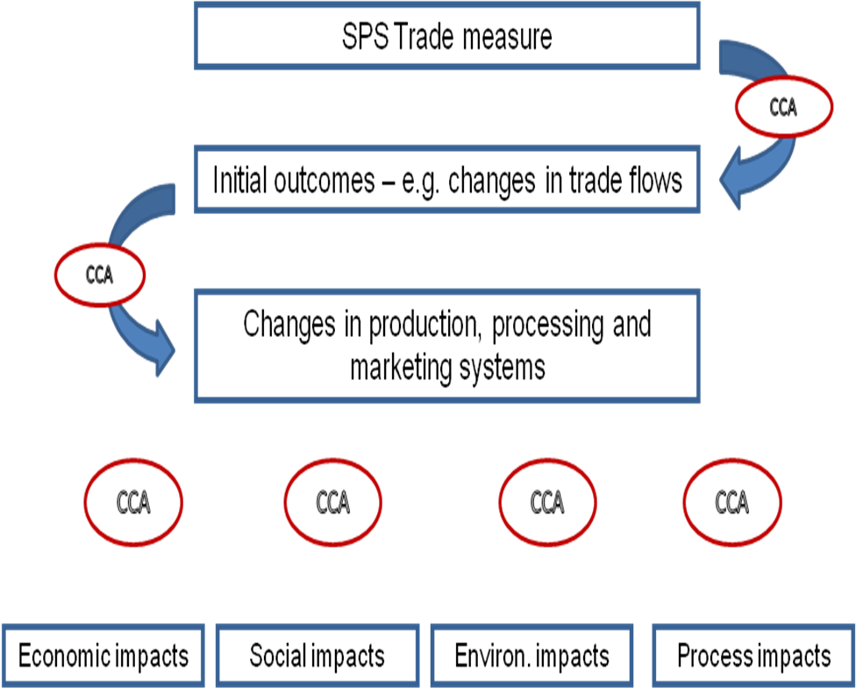
Figure 2: Schematic representation of CCA
Table 1: Sustainability Indicators for Fisheries Sustainability Impact Assessment
Sustainability dimension | Core indicators | Second tier indicators
Economic | Real income  Employment  Fixed capital formation | Levels of production, trade, income levels of different stakeholder groups, expenditure, consumption - payment in kind*,  Govt. revenues (licence fees, taxes, etc);  Levels of employment in fishing and post-harvest fisheries industries, semi-industrial and artisanal employment*;  Size and type of fleet, Gear, Landing and processing infrastructure; etc
Social | Poverty  Health and education  Equity | Indebtedness*, nutrition data, female headed households*, coastal livelihoods and development, coastal-urban migration;  Primary health care, primary education levels, especially in fishing communities;  Income distribution, Asset ownership* (boats and gear, processing, aquaculture); Gender distribution – income and assets*
Environmental | Natural resource stocks  Environmental quality  Biodiversity | Change in fish stocks, change in catch/ composition;  Pollution; changes in eco-systems;  Change in endangered species, change in protected areas, change in fishery;
Process | Consistency  Institutional capacity | Policies on food safety and SPS matters; regional and international commitments; coordination between SPS related institutions  Capacity and commitment at National Notification Authority; National Enquiry Points/Competent Authorities; technical committees

2.2 Value Chain Analysis

2.2.1 Nile Perch Value Chain Mapping
The Lake Victoria fisheries have become integrated into a complex system of supply chains that operate at three distinct levels:
- Localized trading along the lake shore and markets within the hinterland.
- Local trade with urban areas
- Inter-regional trade between Kenya, Uganda and Tanzania.
- Extra-regional international exports.
These chains differ fundamentally in their structure and modus operandi. The supply chain for local consumers and inter-regional trade is characterized by high levels of product diversity across species and levels and forms of processing, including, fresh, smoked and dried fish.

The Nile perch value can be summarized as followers:

Producer (fishermen) – deals with fishing gear
▼
Seller (beach middlemen) – deals with whole fish
▼
Seller (factory agent) – deals with whole fish
▼
Processor (factory) – deals with whole fish
▼
Whole seller (deals with by-products and 2nd Grade fillets)
▼
Importer/Exporter – deals with fish product
▼
Distributor – deals with fish product
▼
Retailer – deals with fish product
▼
Consumer – deals with fish product

There is little or no integration along the chain and in some cases, particularly trade with distant urban areas and/or neighbouring countries, there are numerous intermediaries. This is in stark contrast to the supply chain associated with extra-regional exports (LVFRP, 1999a), that is characterized by:
- High levels of vertical integration in an attempt to control each of the inter-connected stages.
- Low levels of product diversity; the chain only handles one species of fish, namely Nile perch.
- Sophisticated processing facilities that employ trained labour, although the level of processing and value-added is generally minimal and most fish is exported frozen in bulk packs.
- High levels of capital investment and significant economies of scale such that processing facilities need to operate at or near capacity in order to be profitable.
- Utilization of air and sea freight to access distant markets.
To all intents and purposes these two supply chains operate side-by-side but there is very little direct competition between them. Rather, the extra-regional supply chain is supplied as a first resort, with only rejected fish entering the local and regional supply chains.

2.2.2 Lake Victoria fishery
The two main fishing methods for Nile perch on Lake Victoria as a whole are gill netting and longlining. Gill net boats generally have a crew of two or three, although some have as many as four. Most boats target only one species, predominantly Nile perch.
Fishing boats are generally operated by the boat owner or a boat operator on behalf of an absentee owner with a paid crew. The most common form of remuneration allocates a flat proportion of the catch each day to the crew less costs (for example food, fuel, wear and tear of equipment etc) (LVFRP, 1999b). Other forms of payment include the designation of certain days on which the entire catch is divided amongst the crew or the opportunity for the crew to use their own gear to catch fish from the owner’s boat.
The majority of fishers sell their landed catch at their home beach (LVFRP, 1999a; 1999b; Hoekstra et al., 1991). However, there is evidence that landing of fish at multiple beaches and collection and distribution of fish by boat are becoming more common (Gibbon, 1997; Odongkara, 1992). The main purchasers of fish at landing beaches are agents of industrial fish processors, although there is frequently a multitude of other purchasers including bicycle, pick up vehicle traders and local traders/processors (LVFRP, 1999a; 1999b). Relatively few fishers have formal buying arrangements with agents, for example selling fish exclusively to a particular agent in return for credit or gear. This is increasingly the norm for Nile perch (Hoekstra et al., 1991; Geheb, 1997; LVFRP, 1999a).
Local fishing communities experience considerable problems marketing their catch. Particular issues include significant price fluctuations (even on day-to-day basis), transport problems and lack of cold storage/ice (LVFRP, 1999b). In most cases little or no bargaining over the price and/or acceptability of fish takes place; rather the most common scenario is that the price is set by the buyer (LVFRP, 1999a). Recently, an Enhanced Market Information System (EFMIS) has been established. The system provides real time information to the fisher community regarding availability of fish and prices at landing sites, local fish markets. EFMIS aims at assisting the fisher communities with bargaining power.

2.2.3 Fish traders/processors
Fish traders and local processors have always played an important role in the Lake Victoria fishery, although the nature of this level of the supply chain has changed fundamentally as a result of the evolution of the industrial fish processing sector. In particular, agents acting as sole suppliers to a particular fish processing plant have come to play a more prominent role than local traders.
The supply chain for fresh fish normally involves the direct supply of fish to agents from fishers (or through their cooperative society or fisher association). There is very limited use of wholesalers. Thus, the supply chain is shorter and more amenable to coordination and control. This contrasts, for example, to the more traditional supply chain for locally processed fish which can involve both direct sales of fresh fish to the processor or the use of wholesale markets.
Most trading in Nile perch and other fish occurs at the landing beach. Increasingly, however, agents are utilizing transporter boats to gather fish from distant beaches or direct from fishing vessels which is then landed at a single beach. This widens their supply base and enables the newly caught fish to be cooled in ice at the earliest opportunity. The majority of traders/processors only deal with Nile perch (LVFRP, 1999a).

2.2.4 Industrial fish processing
The industrial fish processing sector first started to evolve in Kenya at the start of the 1980s and by 1987 ten factories were operational (Reynolds and Greboval, 1988; Gibbon, 1997). At this time no facilities had been established in Tanzania or Uganda and Kenyan processors sourced fish in all three countries. Initially, factories were situated in Kisumu and Nairobi, but more recently facilities were established nearer to landing beaches in Homa Bay and Migori in an attempt to reduce transport costs and maintain quality. Processing capacity continued to expand in the early 1990s, with the number of facilities peaking at 15 in 1995 (Bokea and Ikaiara, 2000).
Industrial fish processing facilities source raw Nile perch in a variety of ways. The most common is to utilize contracted and/or independent agents that purchase from fishers (either directly or through Cooperative Societies or Fisher Associations) (Abila and Jansen, 1997; LVFRP, 1999a; Mitullah, 1999). Generally, the factory provides transportation from the landing beach and ice, but does not take possession of the fish until it arrives at the factory and has been graded. In many cases factories have a long-standing relationship with their agent. Although there is no formal written contract, there is generally prior agreement on the delivery price and size and quality of fish.
The rapid growth of the industrial fish processing sector was motivated by the high and rising demand for Nile perch in exports markets, particularly within the EU. However, after peaking in the mid-1990s, exports began to diminish because of difficulties relating to the supply of Nile perch and fish quality (Bokea and Ikaiara, 2000). It is estimated that the sector as a whole was operating at 55 percent of its 380 tonne/day capacity in 1997 (Abila and Jansen, 1997), of which three factories accounted for over half of total operating capacity.

3.0 KENYAN SPS SYSTEM DEALING WITH FISHERIES NOTIFICATIONS AT TIME OF THE BAN
In general, the basic elements of a food safety control system were in place in the mid-1990s, although in many cases these were outdated and/or inadequate for the task of complying with food safety requirements in industrialized country markets. The national food safety system in Kenya was managed by various agencies under different ministries and laws. This was with an ultimate aim of promoting public health, protecting the consumer against health hazards and enhancing economic development.
Each agency operated independently to fulfill the function for which it was established. However, the activities at each level required integration into a coordinated system. Although no specific legislation relating to hygiene in the processing and marketing of fish and fishery products was in place, various acts and regulations specified including: Public Health Act; Food, Drugs and Chemical Substances Act; Food Hygiene Regulations; Fisheries Act; and Standards Act. However, legislation was out-dated and not compatible with international standards.
In 1994 it had been decided that the Competent Authority for the purpose of approving processing establishment and factory vessels for export to the EU would be the Public Health Department of the Ministry of Health (Fisheries Department, 2001). This was largely based on the existing responsibility of the Public Health Department to certify goods for export under the Public Health Act. In the case of fish and fishery products, however, multiple agencies had responsibility for inspecting and approving fish processing facilities, namely: Public Health Department, Ministry of Health; Fisheries Department, and KEBS (Fisheries Department, 1998). Both Public Health Officers of the Public Health Department and Local Fisheries Inspectors within the Fish Inspection and Quality Control Unit of the Fisheries Department made weekly random visits to processing establishments. Both had the power to withdraw licenses to process. Further, establishments were audited twice annually by Senior Fisheries Inspectors, whilst KEBS audited annually against the KEBS standard.
Many industrial fish processors had not implemented HACCP quality. Frequently, food safety control was rudimentary and general hygiene procedures and standards were inadequate. At landing beaches there was a lack of awareness, ability and/or unwillingness to comply with basic hygiene procedures. Efforts were already being made to establish an elaborate food safety management system along the fish supply chain that targets the export market and the medium to high-income consumers.
The threat of food-borne diseases was the main cause of fear and loss of consumer confidence in the food safety management system. This indeed was the reason for the ban of Kenyan fish exports to the European Union (EU) between 1996 and 2000, and appropriate measures had to be put in place before the bans were lifted. Kenya has subsequently had to continually cope with higher hygienic market requirements including horticultural produce.
Previous to the ban on exports to the EU, the Kenyan fish sector as a whole had made little progress in restructuring hygiene and other food safety controls. For example, landing beaches had received minimal attention and in many cases lacked even the most basic of infrastructure. Inspection and other government controls were ineffective and constrained by lack of resources. Furthermore, there was very little co-ordination or cooperation between government and the private sector, different levels of the supply chain, and between the individual industrial fish processors. However, the need to address the concerns of the EU as a means to regain market access brought about wholesale and fundamental change to the sector in a relatively short period of time. Indeed, it is evident that much of the effort to enhance capacity was a direct result of the restrictions on exports to the EU. In the period 1998-2002 (and particularly 2001-2002), very major advances were made, such that the controls in place today are largely in conformity to EU requirements.
Human resource capacity for food control varies depending on the mandates of the food control agencies. Professions include public health, food microbiology, chemistry, biochemistry, veterinary medicine, environmental health science, and food science and technology. These professional courses were being offered within the country’s tertiary and higher learning institutions. However, there was serious need for upgrading of knowledge and skills to update the personnel on current developments on food safety and quality control, food and disease surveillance, Hazard Analysis Critical Control Point (HACCP), data management and risk analysis.
Although training in food technology was being provided within the country’s universities (University of Nairobi, Egerton University and Jomo Kenyatta University of Agriculture & Technology), there was no specific element on food safety training. The training curricula at the higher learning institutions had not been adequately responsive to the changing trends in food safety. For this reason, food safety concept had not been well integrated into the organizational operations of the Food control agencies. Thus, for example, although there was an established system for the inspection and licensing of fish processing facilities to ensure minimum levels of hygienic practices, these were poorly enforced. Further, controls on imports and the control and certification of exports were in place, but inadequate.
The Kenya Bureau of Standards (KEBS) was the Government Institution responsible for standardization. KEBS also housed the National Codex Focal Point, which is the case to date. Food standards development was done by technical committees which comprised of all stakeholders including regulatory and research agencies, industry, consumers, producers, academia, professionals and other interested parties. The stakeholders provided the expertise and scientific information and built consensus required in national standards development. In developing standards, priority for reference was given to relevant codex and other international standards (texts) to provide the baseline information on which national standards may be adopted or adapted to suit the national food safety situation. Other reference materials include regional and other national standards, laws and regulations. This was in conformity with international guidelines in standards development.
The administration and implementation of existing food laws and other regulatory requirements was a weak area that needed qualified food inspection services. Perhaps the more fundamental weakness was in the implementation and enforcement of existing regulatory requirements. In general, the number of inspectors and other personnel was inadequate to inspect and monitor compliance on landing beaches and industrial fish processing plants. Indeed the number of fish scouts, for example, had declined due to budgetary constraints which necessitated retrenchment of staff. Whilst inspectors were generally well trained, they were in need of up-dating, for example in the principles of HACCP, and in some cases lacked access to basic infrastructure and equipment. For example, inspectors often had to request transport from the fish processors that they were charged to enforce.
Laboratories, which are an essential component of a food control system, were inadequate in testing capacity. Generally, laboratory facilities were poorly functioning and otherwise outdated. Frequently, levels of staffing were insufficient and/or personnel were in need of retraining. At the time of the ban there were no laboratories in the country that were accredited to the ISO 17025 standard. At the same time, the scope of analysis was also very narrow as the capacities in terms of human resource, equipment, and skills development to cope with emerging issues was limited. The laboratories which were being used for food control purposes included the Government Chemist, Kenya Bureau of Standards (KEBS) and National Public Health Laboratories. None of these laboratories had capacity to test for heavy metals and pesticide residues in fish. Later, the Kenya Plant Health Inspectorate Service (KEPHIS) laboratories were used for pesticide testing. Even though the laboratory had not attained accreditation status, it had initiated the process.
The inefficacy of food safety controls for fish and fishery products in Kenya reflected prevailing capacity constraints in both the private and public sectors. Further, the lack of any cooperation or co-ordination within the industrial fish processing sector meant that collective private sector capacity was missing. The existing system had not been upgraded in line with the growth in exports and was unable to implement effective controls within the context of rapidly evolving food safety standards in its major markets. The public authorities and the supply chain were in a continuous position of problem-solving rather than strategic planning for the enhancement of capacity (Henson & Mitullah, 2004).

4.0 HISTORY OF THE BAN

4.1 Timelines and Events
Towards the end of 1996 Salmonella was detected in a number of consignments of Nile perch from Kenya, Tanzania and Uganda, most notably in Spain. As a result, the Spanish government imposed a prohibition on imports of Nile perch from Kenya, Tanzania and Uganda on 27 November 1996. The Italian Government soon followed suit (Mitullah, 1998). Subsequently, on 4 April 1997 the European Commission introduced a requirement for Salmonella testing of all consignments of Nile perch from the region. Imports were subject to positive release, whereby they were held at the border until test results confirmed that the consignment was free of Salmonella. This requirement was initially applied for a limited period to 30 June 1997, but was subsequently extended to 30 June 1998. The cost of the tests was borne by the importer.
During the second half of 1997, there was an outbreak of Cholera across East Africa largely associated with the heavy rains brought by El Nino. The European Commission had on-going concerns about the efficacy of food safety controls in Kenya, Tanzania and Uganda based on the results of inspections and the detection of Salmonella of consignments of Nile perch. Thus, on 23 December 1997 it introduced a requirement for testing of all consignments of frozen fish from Kenya, Mozambique, Tanzania and Uganda for Salmonella, Vibrio cholerae and Vibrio parahaemoliticus. The cost was covered by the importer. Further, given the time taken for these tests to be undertaken, imports of fresh fish were prohibited. The requirement for Salmonella and Vibrio cholerae testing of marine fish was lifted on 16 January 1998. On 30 June 1998, all requirements relating to border testing of fish from these countries were rescinded. Instead, the Competent Authority in each country was required to provide a declaration with each consignment (as part of the standard veterinary health certificate) that all persons handling fish and fishery products had undergone medical checks.
There was quite widespread criticism of the EU’s prohibition on exports of fresh fish from the region, most notably from the World Health Organisation (WHO). Indeed, the WHO raised the issue at the WTO SPS Committee (WTO, 1998a):
“….although there is a theoretical risk of cholera transmission with international food trade, the weight of the evidence suggests that this risk is very small and can normally be dealt with by means other than an embargo on importation.”
Further, the WHO suggested that it would have been better to deal with these concerns through agreements on good hygiene practice for handling and processing of fish aimed at preventing, eliminating or minimizing the risk of any potential contamination. The European Commission responded that, the inspections it had undertaken on food safety controls in these countries had identified significant deficiencies and that, once proper safeguards and modifications had been put in place, the EU would accept these procedures as an alternative to the ban on imports of fresh fish and border testing of frozen fish (WTO, 1998b).
During the period July 1998 to March 1999, no specific restrictions were applied to Kenyan exports of Nile perch and other fish and fishery products. However, in March 1999 a suspected case of fish poisoning with pesticide was identified in Uganda. The Ugandan authorities responded by suspending all exports on 22 March 1999. The Kenyan and Tanzanian Department imposed a two week ban on fishing and trading of Lake Victoria fish and implemented monitoring of water, sediment and fish according to a defined sampling plan. Further, the local community was made aware of the issue through meetings and seminars and community-based vigilante groups were established to ensure compliance. However, given that exports were not suspended and that fish from neighbouring-country waters was known to be landed in Kenya and Tanzania, the EU imposed a ban on exports of fresh and frozen Nile perch on 12 April 1999.

Table 2: Summary of food safety restrictions on Kenyan fish exports to the European Union
Dates ban imposed | Date ban lifted | Restrictions | Products/Regions
27 November 1996 | 3 April 1997 | Exports prohibited to Spain and Italy due to salmonella | Nile Perch
4 April 1997 | 30 June 1998 | Border testing of all consignments for Salmonella | Nile Perch
23 December 1997 | 30 June 1998 | Exports prohibited to the EU | Fresh fish
23 December 1997 | 30 June 1998 | Border testing of all consignments for Vibrio cholerae and Vibrio parahaemoliticus | Frozen/ processed fish not caught at sea and directly landed to EU
25 March 1999 | 1 December 2000 | Exports prohibited to EU due to alleged use of pesticides | Fish from Lake Victoria

Table 3: List of Rapid Alerts as from EU Rapid Alert System for Food and Feed (RASSF) during and after the Ban
Date | Product | Reason
1st Feb 1999 | Chilled Nile Perch fillets | Salmonella
25th March 1999 | Nile perch fillets | Pesticides
26th March 2003 | Frozen Nile Perch | Salmonella
6th August 2003 | Nile perch | Mesophiles
21st Aug 2003 | Chilled Nile perch fillets | Salmonella
28th Dec 2006 | Chilled Nile perch | Salmonella
19th Jan 2007 | Chilled Nile perch | Salmonella
22nd Sept 2008 | Chilled Nile Perch | Salmonella

The length of time for which exports of Nile perch to the EU were prohibited varied significantly across the three countries. The EU undertook inspections in Tanzania towards the end of 1999 and subsequently the restrictions were lifted on 31 January 2000, subject to a declaration in the standard veterinary health certificate that the product had been produced under monitoring checks for environmental contaminants such as pesticides. The first date of fish exports after the third ban was lifted was 29th January 2001. Inspections were undertaken in Uganda in mid-2000 and the restrictions were lifted, subject to a comparable declaration on 4 August 2000. In the case of Kenya, however, restrictions were not lifted until 1 December 2000.

4.2 Measures Taken
Specific restrictions on exports of fish and fishery products to the EU took place within a broader program of inspections of hygiene controls in Kenyan by the European Commission. Over the period 1997-2001 a total of three inspection visits took place. Indeed, Kenya was not included in List II until January 1999 and only achieved List I status after December 2003. This contrasts with Tanzania and Uganda, which were added to List I in July 1998 and August 2001 respectively.
When the European Commission undertook inspections in Kenya in 1998 it found that, despite major improvements having been made in the light of previous inspection reports, significant deficiencies remained (European Commission, 1998). Concerns related to the inspection and approval of processing facilities, some of which were considered not to comply with EU hygiene standards, hygienic conditions at landing beaches, laboratory infrastructure, and use of identification marks on consignments of fish for export.
The European Commission undertook a further inspection visit in 1999 to assess the efficacy of controls on pesticides in the light of the restrictions in place on exports of Nile perch to the EU at that time (European Commission, 1999). Whilst concerns were raised about the monitoring and sampling programs that had been implemented by the Kenyan authorities, the most significant weakness was related to laboratory infrastructure. Whilst the laboratory of the Kenya Plant Health Inspection Service (KEPHIS) was considered generally acceptable, the facilities and methods of analysis employed at the laboratory of the Government Chemist were considered inadequate, such that results communicated to the European Commission could not be considered accurate and reliable.
In March 2002, a European Commission mission again visited Kenya, both for the purpose of assessing compliance with EU hygiene standards with a view to inclusion in List I and monitoring measures relating to pesticide residues in fish (European Commission, 2003). The overall impression of the inspection team was positive, although some relatively ‘minor’ nonconformities were identified. In particular, the pesticide monitoring program that had been communicated to the European Commission by the Kenyan Government had not been fully implemented and improvements were required in procedures for laboratory analysis. Some nonconformities were identified in processing establishments, most of which had already been recognized by the Competent Authority although no action had been taken. Finally, hygienic conditions at landing sites were considered to be in need of improvement. The Kenyan Government provided written confirmation to the European Commission regarding the necessary improvements. Subsequently, special import conditions were laid down in December 2003 and Kenya was added to List I. Notable changes that have been brought about as a direct result of the ban on exports include:

- The formation of the Association of Fish Processors and Exporters of Kenya (AFIPEK):
AFIPEK is the first real attempt by the industrial fish processors to cooperate with one another and present a united front to the Government of Kenya and international and intergovernmental agencies, for example the European Commission and providers of technical assistance such as FAO and UNIDO.
- Reorganization of administrative responsibilities within government for the regulation of the fish sector:
The rationalization of administrative responsibilities such that the Fisheries Department now has sole responsibility for regulation of the fish sector, including the inspection and approval of processing establishments for export to the EU, facilitates more effective development and implementation of controls and effective and timely response to emerging issues.
- Establishment of a Competent Authority
In August 2002, the Fisheries Department was made the Competent Authority and given sole responsibility for food safety controls relating to fish and fishery products and the approval of processing establishments and issuance of Fish and Fishery products Export Health Certificates.

5.0 IMPACT OF THE EU BAN ON NILE PERCH IMPORTS FROM KENYA

5.1 BASELINE SCENARIO

5.1.1 Value Chain Situation before the Ban
During the 1960 and 1970s, the Kenyan landed catch from Lake Victoria was stable at around 100,000 tonnes per annum (Abila and Jansen, 1997). At this time, the fishery was exploited solely by local fishers, 80 percent of which derived their primary income from fishing. Although average earnings declined as the number of fishers on the lake increased (Francis and Hoddinott, 1983), income was distributed fairly evenly within the community. There were considerable investment barriers such that most boat owners had a single vessel and only sufficient gill nets that they could handle themselves.
Traditionally, the fishery consisted of wooden crafts propelled by sail. Very few had motorized propulsion. Throughout the 1960s and 1970s there was very little improvement in technology. This served to constrain the effectiveness of the fishing effort and thus limit the level of exploitation at sustainable levels (Geheb and Binns, 1997). Further, fisheries resources were managed judiciously and in a sustainable manner, with indigenous rules and regulations safeguarding fishing activities.
A vibrant artisanal processing and trading sector co-existed with the fishery, based on or near to landing beaches. This was dominated by small-scale operators, mostly women, from the local community. Fish that was not sold fresh was processed by smoking or sun-drying and carried to local inland markets. In general, the wholesale sector was relatively small and traders had little market power. Most fishers sold fish to a limited number of fishmongers with which they had a long-standing relationship (Abila and Jansen, 1997).
Prior to 1980, the Lake Victoria fishery existed largely without outside interference. Whilst the fishery was subject to regulation under the Fisheries Act, this was largely un-enforced (Abila and Jansen, 1997). Whilst the Fisheries Department collected catch statistics through Fish Scouts, these were largely employed from the local community. Instead, the fishery was regulated by local norms and customs which determined who was entitled to fish, in which seasons, which areas, types of fish gear that could be used, size of fish that could be landed etc.
During the early to mid-1980s, despite significant expansion, the Kenyan Lake Victoria fishery continued to be almost exclusively exploited by small-scale local fishers. There were no major changes in technology and practices and many women were involved in the processing and marketing of fish locally. However, towards the end of the 1980s, the Nile perch fishery changed dramatically. Thus, the number of fishers increased steadily from 11,000 in 1971, to 22,000 in 1989 and 30,000 in 1995. The number of fishers was recorded as 196,426 in 2006 (Regional Frame survey report 2006). There was also significant growth in the number of registered vessels from around 4,000 in the early 1970s, to 5,000 in the late 1980s and over 11,500 in 2000. Simultaneously, there was investment in more advanced fishing equipment, in particular gill nets with larger mesh sizes (Abila and Jansen, 1997).

5.1.2 Lake Victoria Fisheries Production and local value chains before the Ban
In 1996, fish production in Lake Victoria (Kenya waters) continued to be dominated by two non-indigenous fish species namely Nile perch (Lates niloticus) and Nile Tilapia (Tilapia niloticus) and the endemic cyprinid Rastrineobola argentea (Omena). Most of traditional fish species such as Alestes, Barbus, Labeo, Synodontis, Schilbe appeared to be disappearing from the commercial catches of the lake. Catches of other traditional fish species like Propterus, Clarias, Mormyrus and one abundant Haplochromis had started to decline considerably from their nominal weight in the early 1980's.
In the same year (1996) a total of 166,460 metric tonnes of fish valued at 6,129,838 thousands Kenya shillings to the fishermen were landed along the shores of the Kenya sector of Lake Victoria by some 30,000 fishermen operating 8,000 fishing boats. This was a decline of 8.5 per cent in nominal weight while there was an increase of 31.0 percent in value to the fishermen as compared with the previous year (1995) figures. This decline in catches can be attributed mainly to the invasion of the lake by the notorious water hyacinth scientifically known as Eichornia cresspies. This weed closed off some fishing grounds and made navigation very difficult thus raising the fishing effort needed to catch a given quantity of fish. Another explanation for the decline was the continued overfishing which has resulted in reduced fish sizes. The increase in value can largely be attributed to increased overall fishing effort which was stimulated by growing demand for fish on both local and the export markets.
From around 1991 to 1995 the lake's species catch composition by weight witnessed major changes. The catch composition of Nile Perch (Lates niloticus) rose sharply from 31 per cent in 1991 to 58 per cent in 1996 while that of Tilapia species declined from 25 per cent to 9 per cent over the same period. The catch composition for Omena (Rastriniobola argentea) appeared to stabilize at 25 - 30 percent. The catch composition for all other species declined at different rates (Fisheries Department, 1996).
Nile perch, which is the main stay of the fish processing plants in the country, made a significant contribution to the fishing industry. Catches of this species amounted to 96,471 metric tons representing more than half (57.95%) of the catch from Kenyan lakes in 1996. Rastrineobola argentea contributed 49,670 metric tons (or 29.84%) while Tilapia species contributed 15,888 metric tons (or 9.54%) of the total landings. All the other species combined contributed the remaining 2.67 percent. On the prices the most expensive species from this lake in 1996 was Nile perch (Lates niloticus), selling at KShs. 49.50 per kilo on average while the cheapest species was Rastrineobola argentea selling at KShs. 14.35 per kilo landed (Fisheries Department, 1996).
In 1996, there was already concern that exploitation of the natural resources in Lake Victoria must be effectively managed and environmentally sustained to assure present and future socio-economic development opportunities. At the moment the lake appeared to be fully exploited and there was need to establish what levels of fishing efforts that could be supported. There was also proposal to use appropriate fishing gears for sustainable exploitation in order to avoid depletion or disappearance of certain stocks.

5.1.3 Nile Perch Exports prior to the Ban
Until the later 1980s, exports of Nile perch were negligible. The expansion of the Lake Victoria fishery was largely directed at supplying local markets and trade within regional markets, much of which was ‘undocumented’. International trade in Nile perch became established in the mid- 1980s and expanded rapidly through to the mid-1990s. Thus, the volume of exports increased from 102 tonnes in 1985 to a peak of 19,300 tonnes in 1994. Simultaneously, the price of Nile perch increased on international markets, thus the value of exports increased from US$0.1 million in 1985 to US$43.9 million (3.4 billion shillings) in 1996.

Figure 3: Exports of fresh, chilled and frozen fish fillets, 1984-1996 (tonnes):
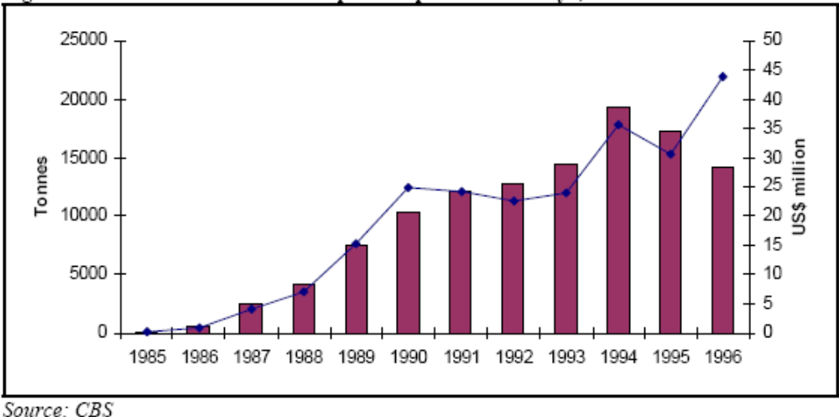

Since 1987 when fish exports made a landmark, fish exports have been performing well especially on the value added element. For example in 1987, 1,777 metric tons of fish and fishery products worth 142 million Kenya shillings were exported compared to 1996 exports of 18,892 metric tons worth 3.4 billion Kenya shillings. The export trend had been consistent and encouraging and this can be corroborated by the number of firms entering the marketing either to sell fresh fish or to fillet the same for export.
In 1996 a total of 18,892 metric tons of fish and fishery products were exported earning the country 3,426,023,000 Kenya shillings in foreign exchange. The bulk of the exports were Nile Perch fillets which contributed 16,477 metric tonnes (or 87.2 per cent) worth 2,881,132,000 Kenya shillings. The major export market for Nile perch fillets were Greece, Germany, Netherlands, Israel and Singapore. The other fish and fish products which contributed to this huge export figure were in the form of molluscs (mainly octopus and squid), crustaceans (Lobsters, Prawns, Crabs and freshwater Cray Fish), live fish mainly ornamental fish, dry shark fins, fish meals, marine shells, dried salted fish, Bonitos and Beche-der-mers.
During the early and mid-1990s, the EU was the dominant market for Kenyan exports of fish and fishery products. For example, in 1996 the EU accounted for around 65 percent of fish filet exports. The Netherlands alone accounted for over 28 percent of exports. Germany, Greece and Spain were other major EU markets. The most significant non-EU markets were Israel, accounting for 21 percent of exports, and Japan.

5 .2 INITIAL OUTCOMES

5 .2.1 Lost Exports
Kenya, until 1996, relied heavily on the EU market for her fish exports. The EU imported 70% of Kenya’s fish exports, with Spain importing the bulk of the commodity. A ban was imposed on Kenyan fish exports by Spain and Italy, on the 27th November, 1996, claiming the presence of Salmonellae in fish (first ban). At this time, these two countries accounted for 7.5 percent of fresh fish exports and 6.7 percent of total fish exports. As a result of the ban, both production and export of fish dropped significantly, negatively affecting the fishing folk’s livelihood. The effects of the ban were felt in 1997, where a 13.1% drop in the foreign exchange earnings was experienced. This was occasioned by a 33% drop in quantity of fish exported to the EU in 1997, compared to the previous year. The quantity of Kenyan fish exports to Spain declined by 86% in 1997 compared to 1996 exports.

Figure 4: Effect of fish ban on Nile perch production
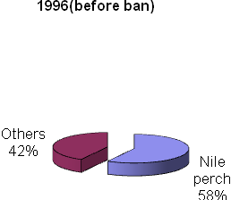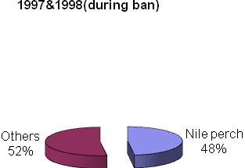
Source: Fisheries Department

On 23rd December, 1997, a ban on fish from East African countries and Mozambique was imposed by the EU as a result of Cholera outbreak in these countries (second ban). This ban affected only fresh chilled fish exports. The World Health Organization (WHO) came to the rescue of the four countries with the reassurance that Cholera cannot be transmitted to human through fish that has undergone hygienic processing. The ban was, therefore, lifted on 30th June, 1998.
In 1998, a total of 17,816 metric tonnes of fish and fishery products were exported valued at Kshs. 2,510,659 thousands. The following year (1999) 18,145 metric tonnes were exported earning the country Kshs. 2,191, 280 thousands. Although there was an increase in 1999 in quantity exports, the corresponding earnings were lower. This was due to lower prices that were offered by markets outside European Union (E. U.) for Lates niloticus (Nile Perch) fillets.
The cholera ban greatly affected Nile perch exports to the EU, causing a 66% drop in quantity exported in 1998, compared to the previous year. The overall effect of the ban to Kenyan export market was a 24% drop in total quantity of fish exports, accompanied by a 32% drop in value of foreign exchange. The EU is a valued market for Kenyan fish and though exports to other destinations continued to grow, the ban significantly affected both the fishers and foreign exchange earnings as evidenced by the decline in quantity and foreign exchange earnings. The rise in quantities of fish exports to other destinations was, therefore not been matched by commodity value. The EU market offered better value for Kenyan fish compared to other destinations.
On 26th March, 1999, another ban (third ban) was imposed EU on fish from Lake Victoria affecting the three riparian states. This ban was imposed due to alleged use of chemicals by fishers to harvest fish. The quantity of Nile perch exports to the EU dropped by 68% in 1999 compared to the previous year. The market had diversified a little with quantities exported to other destinations increasing slightly by 2%, though without equivalent financial gains. The EU pays more for Kenyan fish compared to other destinations. There was a 16 % rise in the value of exports compared to the previous year, which was nevertheless 31% less than the value before the bans in 1996.

Figure 5: National and Nile Perch Exports; Quantity and Value 1996 - 2003
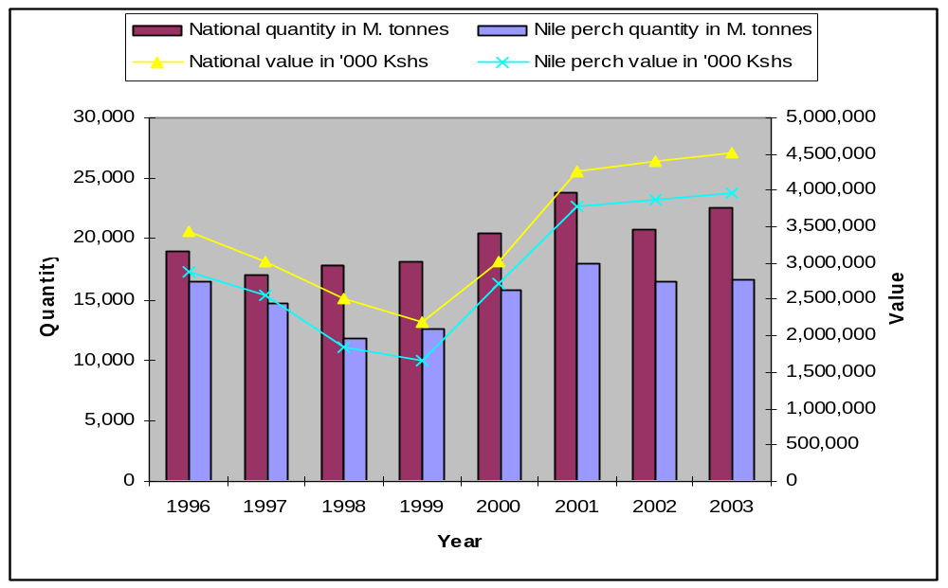
Source: Fisheries Department (2002)

4.2.2 Changes in Trade Flows
Historically, the EU has also been the major market for Kenyan exports of frozen fish fillets, accounting for around 60 percent of exports in 1996. Close proximity and well-established connection, translating into lower sea freight costs, combined with higher prices for Nile perch have made EU countries an attractive market.
In 1997, European Union (E.U.) member countries imported most of the fillets (7,701 metric tons) followed by Israel (4,095 metric tons), Asian countries ( 1,447 metric tons ) and other countries combined imported only 1,476 metric tons. Although a ban had been slapped on Kenyan fish from L. Victoria by Spain and Italy on the 27th November 1996, claiming the presence of Salmonellae in fish, some EU member States were, however, not influenced by the ban and therefore continued to import fish from Kenya on bilateral agreements.

Table 4: Exports of fresh, chilled and frozen fish fillets by destination, 1997-2002 (Tonnes):
Country | 1997 | 1998 | 1999 | 2000 | 2001 | 2002
Israel | 4244 | 5252 | 4550 | 7160 | 3984
Netherlands | 3033 | 856 | 3208 | 26 | 4126
Singapore | 1669 | 745 | 532 | 910 | 346
Germany | 1550 | 175 | 298 | 0 | 1449
Greece | 789 | 1002 | 183 | 0 | 103
Japan | 387 | 1221 | 1951 | 2183 | 1234
Malaysia | 318 | 36 | 87 | 360 | 399
France | 309 | 19 | 0 | 0 | 0
United States of America | 288 | 134 | 167 | 415 | 1491
Portugal | 244 | 25 | 124 | 0 | 166
United Arab Emirates | 222 | 352 | 233 | 449 | 440
Belgium | 208 | 27 | 7 | 1 | 822
Hong Kong | 175 | 173 | 235 | 1226 | 211
Australia | 174 | 772 | 1829 | 1439 | 2083
Italy | 1 | 0 | 0 | 0 | 402
Other | 452 | 200 | 547 | 1359 | 649
TOTALS | 14064 | 10989 | 13949 | 15528 | 17906
Source: CBS (2002)

In order to remain in business despite the different bans and rapid alerts from the EU, processors/exporters of fish diversified their markets, mainly outside the EU where food safety requirements were not very stringent. Exports of processed Nile perch to non-EU destinations rose steadily over the period of the ban, while those to the EU dropped. Therefore, the ban on Kenya’s Nile perch exports to the EU opened opportunities for new markets.

Figure 6: Nile perch export by (processed) weights to EU and other destinations vs. respective total export value 1996 – 1999
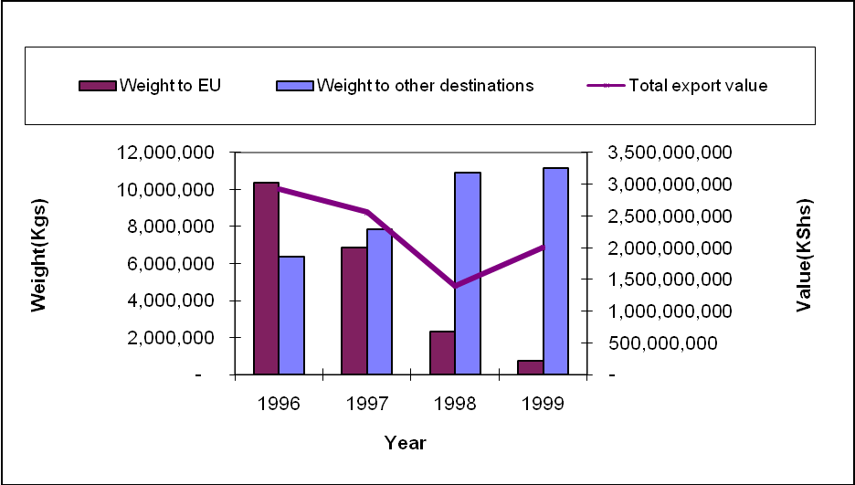
Source: Fisheries Department (2001)

4.2.3 Changes in Relative Prices
From 1997 to 2000 fish prices at the landing sites depended on the accessibility of the sites by fish buyers (mostly processing plants) and on prevailing market forces of supply and demand for a particular fish species. Thus fishers that landed their fish catches at sites that were easily accessible (by traders) could afford to bargain for higher prices. The average ex-vessel price of Lates niloticus (Nile Perch) fell to as low as 20 Kenya shillings per kilo during the ban at some landing beaches; after the ban the price shot up to 50 and then to 70 Kenya shillings per kilo. Over the three year period between 1998 and 2000 the average ex-vessel price of all Tilapiines dropped sharply in 1999 and remained at the same level through the year 2000, while the corresponding price of Rastrineobola argentea remained stable over the same period (1998 – 2000) at about 18 Kenya shillings per kilo (Fisheries Statistics Bulletin, 1998-2000).
Although the onset of restrictions on exports to the EU resulted in an immediate decline in the landed price of Nile perch, this was soon at least partially offset by a decline in fishing effort applied to Nile perch and demand from local markets (Abila and Jansen, 1997; Bokea and Ikaiara, 2000). Further, expanded markets soon became established in urban centres, particularly Nairobi, Mombasa and Nakuru. For example, Nile perch became regularly available at the City Market in Nairobi whereas previously it had been rarely offered for sale. Thus, the real price of Nile perch declined from KSh45.5 per kilogram in 1996 to KSh27.4 per kilogram in 1997, but recovered to KSh36.9 per Kilogram in 1998.

Figure 7: Mean annual landed price of Nile Perch in Kenyan areas of Lake Victoria, 1996-
2002:
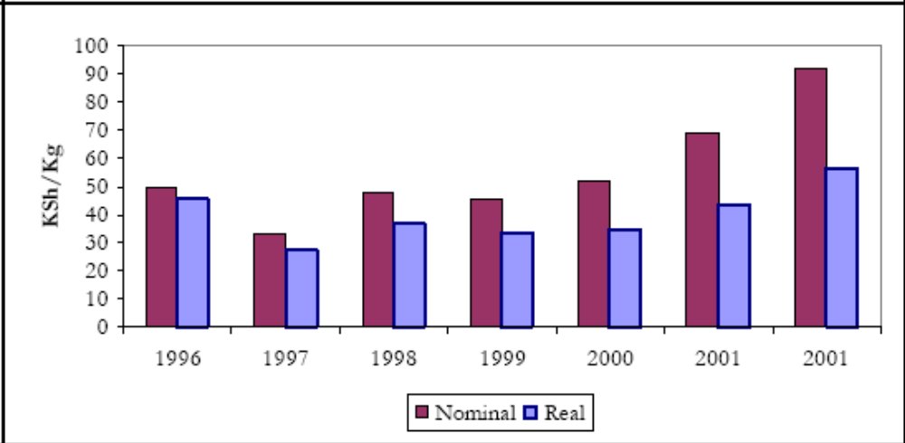
Source: Fisheries Department.

The unit price of frozen fish fillets in non-EU markets remained stable through the period 1996- 98, reflecting the greater number and variety of markets available to exporters and their ability to divert supplies between these according to market conditions. However, the price of frozen fillets did decline in the EU such that the differential between EU and non-EU market prices was almost eradicated by the end of 1998. Through 1999 and 2000, however, EU prices recovered and in 2001 there was a premium of over 15 percent over frozen fillet exports to non- EU markets.

5.3 CHANGES IN PRODUCTION, PROCESSING AND MARKETING SYSTEMS

5.3.1 Changes in Production System
Although the production system for Nile perch in Kenya had started changing just before the ban because it had become export oriented, most landing sites were seriously underdeveloped with regard to food safety management. The vessels used for fishing were generally fishing boats and fishing crafts. The fishing boats were made of wooden construction which is not easy to clean and sanitize. In order to comply with the requirements set by the EU with regard to food safety management at the primary production level, the production system had to be adapted in various ways.
The majority of landing beaches along the Kenyan shore of lake Victoria only had rudimentary infrastructure. Indeed, in 1998 only 27 percent had a permanent covered structure (banda) for grading and marketing of fish. Only 20 percent had an all-weather road to the beach. Very few landing beaches had any form of fish and/or cold storage. Where existing, these were typically cooler boxes that required ice to store fish for prolonged periods of time. In some cases these had been donated by research projects that had been completed or had been constructed by a fish trader or supplied by processors to traders or agents.
A number of efforts have been made to organize fishers at each landing beach. During the 1970s, existing fisher organizations were converted into Fishermen Cooperative Societies administered under the Cooperative Act and promoted and managed by the Ministry of Cooperative Development. These aimed to assist fishing communities in the marketing of fish, mobilization of savings for beach improvement, provision of credit to fishers and, more generally, to improve the standard of living of the communities (Jansen, 1997; Abila, 1995; 1998). Over time and into the 1990s, the number of cooperatives increased significantly. However, during the 1980s and 1990s many became dormant or were under-utilised., whilst others collapsed or were disintegrated (Ong’ang’a, 2002).
In the early 2000s, fisherfolk associations emerged as a new form of organization as a means to by-pass the problems encountered with cooperative societies, and to address specific fish management problems. These were registered by the Ministry of Culture and Social Services, although it had no remit to promote their establishment and/or supervise their operations (Ong’ang’a, 2002). Today, cooperative societies and fisherfolk associations operate side-by-side and fishers are frequently members of both. Increasingly, however, the fisherfolk associations have come to dominate the marketing of fish.
Before the ban, a Beach Leader was appointed by the community on most beaches along the Kenyan shore of Lake Victoria. This individual was recognized by the Fisheries Department, although there was no legal provision in the Fisheries Act. The Beach Leader headed a committee of five to seven community members and was charged with ensuring fishing was undertaken in compliance with rules and regulations, promoted peace and security at the beach, solved misunderstandings between fishers and fishmongers and received and approved immigrant fishers. More generally, the Beach Leader acted as an intermediary between the community and the Fisheries Department and promoted the development of infrastructure at the beach.
After the ban, Beach Management Units (BMUs) have been established at landing beaches in an attempt to effect management of fishing communities and communication with local fisheries officials. In compliance with the various regulatory requirements on hygiene, the BMUs have become an important entry point for training and enforcement of rules.

5.3.2 Changes in Processing
Before the ban a significant proportion of traders/processors experienced problems with fish spoilage (LVFRP, 1999a).These problems are related in particular to poor storage conditions and, where trading occurs in the open air, rain. Another significant problem faced is transportation, due largely to the poor state of the roads in the region.
Being cautious of food safety requirements that were introduced during the ban, fish processors have adopted Good Hygiene Practices (GHP) for their fish supplies, and a complete Food Safety Management system based on Hazard Analysis and Critical Control Points (HACCP). In this system, processors have developed a hazard control plan for their fish supplies, and a HACCP plan for the processing facilities. Even after the bans were lifted, upgrading of facilities and maintaining the HACCP food safety management system has become the norm rather than the exception. The factories/processing plants must now be inspected by the competent Authority (CA) for compliance to hygiene and food safety requirements.
From the time the EU ban was imposed to fish exports from Kenya, it became extremely necessary that processing plants employ qualified personnel and regularly send them for refresher food safety training. Fish factories were forced to replace unskilled personnel for more specialized tasks like quality control. By 1997, the industrial fish processing sector employed around 2,400 people, of which 75 percent were temporary or casual workers (Abila and Jansen, 1997). However, there is evidence that overall employment in fish processing has declined significantly over time, reflecting the relatively high levels of capital intensity within the industrial processing sector.
Due to rapidly dwindling Nile perch stocks, industrial fish processing facilities source raw Nile perch in a variety of ways so as to have sufficient quantities to process. The most common is to utilize contracted and/or independent agents that purchase from fishers (either directly or through Cooperative Societies or Fisher Associations) (Abila and Jansen, 1997; LVFRP, 1999a; Mitullah, 1999). Generally, factories now provide transportation from the landing beach and ice, but do not take possession of the fish until it arrives at the factory and has been graded. Transport of fish from different beaches is an expensive process. Processing factories who do not have sufficient collection trucks find it difficult to gather enough supplies for processing.
In the recent past, many fish process can no longer acquire sufficient volumes for processing. Apart from cutting down the workforce per day, processing only on particular days has become a practice. A number of processors provide financial support to agents, for example in the form of cash advances to purchase fish. They may also supply fishing equipment to fishers through agents in a bid to establish sole supplier relations. The typical agent can handle three to five tonnes of fish in a day and earns commission of around 10 percent, as the difference between the purchase and selling price (Abila and Jansen, 1997). In many cases factories have a long-standing relationship with their agent. Although there is no formal written contract, there is generally prior agreement on the delivery price and size and quality of fish. The delivery price is usually much higher than the price at the beach. Price fluctuations do not therefore interfere with the profits for the agent.
The rapid growth of the industrial fish processing sector was motivated by the high and rising demand for Nile perch in exports markets, particularly within the EU. However, after peaking in the mid-1990s, exports began to diminish because of difficulties relating to the supply of Nile perch and fish quality (Bokea and Ikaiara, 2000). It is estimated that the sector as a whole was operating at 55 percent of its 380 tonnes/day capacity in 1997 (Abila and Jansen, 1997), of which three factories accounted for over half of total operating capacity.
Although fish processing plants continued primarily to handle Nile perch, some started to process tilapia for export towards the end of the 1990s (Abila and Jansen, 1997). There was also consolidation in the sector and a number of operators established sister factories in Tanzania and/or Uganda where the supply of fish had been more plentiful. Until recently, these were used in part as a source of supply of raw or semi-processed fish for their Kenyan plants (Mitullah, 1999).

5.3.3 Changes in Export Marketing System
As a result of the ban of fish exports to the EU, Kenyan exporters of sought for alternative markets including other industrialized countries such as Australia, USA, Japan and Hong Kong, as well as a number of middle-income countries in Latin America, Asia and the Middle East. The share of exports to non-EU markets drastically rose during the period of the restrictions to EU markets. Although exports of chilled fillets initially stopped, the opening of alternative markets necessitated exports in the form of block frozen fish fillets. The block frozen fish had a significantly lower price than fresh fillets. Besides, the alternative markets generally paid a lower price for Nile perch fish fillets than the EU. The unit value of fish exports was therefore much lower over the period of the ban.

Figure 8: Total Lates niloticus fillets Exports 1996-2000 during the EU ban
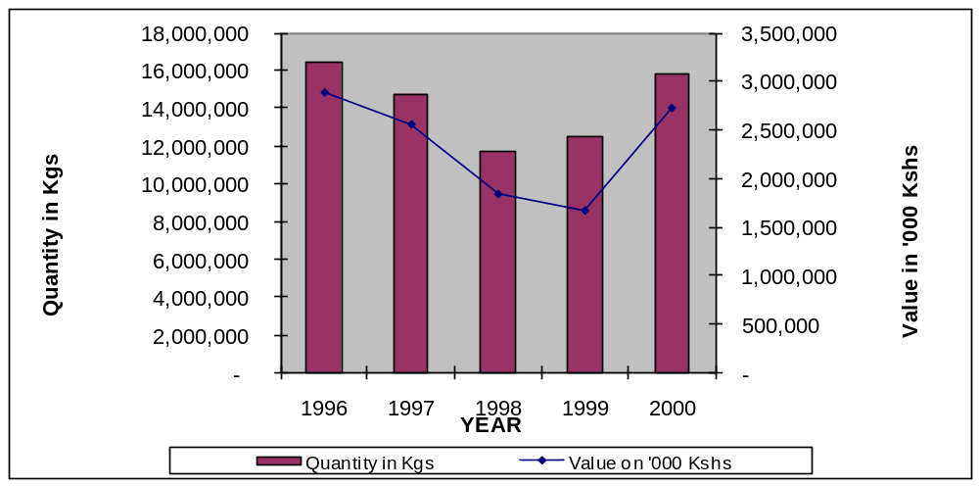
Source: Fisheries Department

In 1998, a total of 17,816 metric tonnes of fish and fishery products were exported. The following year (1999) 18,145 metric tonnes were exported while during the year 2000 there was big increase in exports to the tune of 20,510 metric tonnes. The country earned 2,510,659,000 Kenya shillings in foreign exchange from the exports in 1998. In 1999 the earnings were Kshs. 2,191,280,000 while in the year 2000 the country earned Kshs. 3,014,181,000. Although there was an increase in 1999 quantity exports, the corresponding earnings were lower. This was due to lower prices that were offered by markets outside European Union (EU) for Nile perch fillets. From 1997, fish export prices have been declining year after year, but Nile perch exports remained higher than of other fish species.
As the EU had been an important and high-value market for fresh Nile perch fillets the restrictions lowered the unit price of fresh fillets declined in both EU and non-EU markets exporters competed more intensely within a diminished market. The unit price of frozen fish fillets in non-EU markets remained stable through the period 1996-98, reflecting the greater number and variety of markets available to exporters and their ability to divert supplies between these according to market conditions. Through 1999 and 2000, however, EU prices recovered and in 2001 there was a premium of over 15 percent over frozen fillet exports to non- EU markets.

5.3.4 Changes in Domestic Market System
Whilst the onset of restrictions on exports to the EU resulted in an immediate decline in the landed price of Nile perch, this was soon at least partially offset by a decline in fishing effort applied to Nile perch and demand from local markets (Abila and Jansen, 1997; Bokea and Ikaiara, 2000). Further, expanded markets soon became established in urban centres, particularly Nairobi, Mombasa and Nakuru. For example, Nile perch became regularly available at the City Market in Nairobi whereas previously it had been rarely offered for sale. Thus, the real price of Nile perch declined from KSh45.5 per kilogram in 1996 to KSh27.4 per kilogram in 1997, but recovered to KSh36.9 per Kilogram in 1998. However, it was not until 2001 that the landed price fully recovered in real terms, despite a significant increase in the nominal price throughout the period 1997 to 2001. Subsequently, through 2002 the landed price of Nile perch increased significantly in both nominal and real terms, reflecting the decline in the volume of catch and competition between industrial fish processing operating well below capacity.
Whilst the landed price of Nile perch declined directly restrictions were imposed on exports to the EU, the price of other fish increased or remained constant. In particular, the landed price of Tilapia (Tilapia niltoticus) increased significantly through 1997 and 1998, and in both years actually exceeded the price of Nile perch. This is in stark contrast to the previous twenty years, during which time the price of tilapia was both lower than and declined relative to the price of Nile perch. Thus, one of the responses by fishers to the diminished market demand and price for Nile perch was to increase the effort devoted to other fish species and landed volumes increased significantly, although subsequently declined through 2002 (Henson & Mitullah, 2004).
Figure 9: Mean annual landed price of Nile Perch in Kenyan areas of Lake Victoria, 1996-2002:
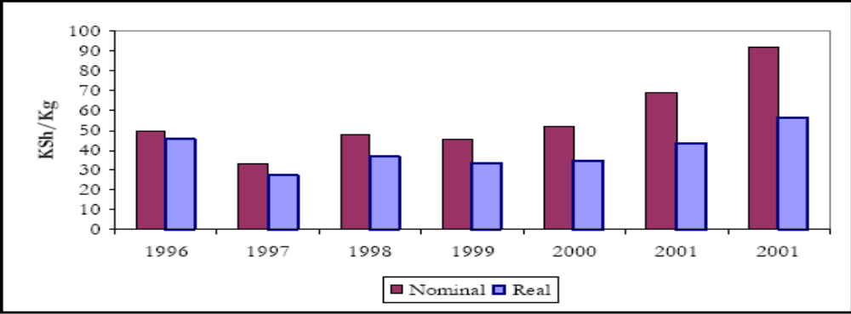
Source: Fisheries Department

5.4 IMPACTS

5.4.1 Economic Impacts
It is important to note that the restrictions on exports to the EU were imposed at a time when the landed catch of Nile perch was already in decline. For example, over the period 1994-96 the landed volume dropped from 103,995 tonnes to 96,471 tonnes. Loss of access to EU markets immediately resulted in a reduction in demand for raw fish as industrial processing facilities ceased operating or reduced output. The local market was unable immediately to absorb the surplus, and the catch declined significantly in 1997 as fishers reduced their fishing effort and/or diverted attention to other fish, in particular tilapia (Henson & Mitullah, 2004).

Figure 10: Value of Nile Perch Exports 1996-2002
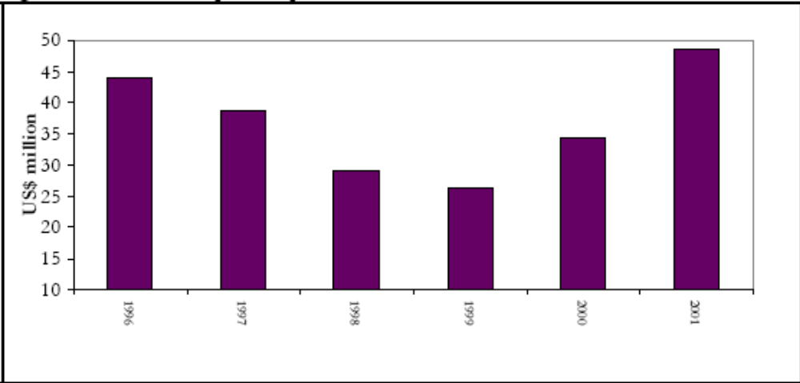
Source: Fisheries Department

In view of the decline in artisanal processing at landing beaches and the inability of local markets to absorb significant additional volumes of Nile perch, any decline in demand was generally absorbed through reductions in the landed price of fish. In turn, because of the limited alternative sources of cash incomes available to fishers this generally translates into a decline in earnings within the local fishing communities (Mkisi, 1991; Jansen, 1997).
Nile Perch (Lates niloticus) fishery is the main lucrative commercial enterprise for the Lake Victoria fishers as most of its landing is processed and exported. As the Nile perch was not traditionally consumed in Kenya, its entry into the domestic marketing chain was very minimal. Besides, limited quantities that ended up in the domestic fresh markets fetched much lower prices than Tilapia. Even for smoke dried fish, Nile perch was not the preferred product in the market. A large number of fishers and related businesses that depended on Nile perch exports were affected, and this can be demonstrated by the numbers of fishers recorded in 2002. In the year 2000, there were 38,431 fishers operating from 297 landing beaches along the Kenyan shore of Lake Victoria (Fisheries Department, 2000) compared with year 2002 when fishing effort stood at 54,163 fishers using 12,209 fishing crafts. The fishers utilized a total of 130,708 gill nets of various mesh sizes, 2,562,066 long line hooks, 1,157 beach seines, 102 cast nets, 12 scoop nets, 12,172 hand lines, 2,311 traps and 2,097 mosquito nets (Lake Victoria Frame survey, 2002). With limited alternatives available to the fishers during, the bans many fishers and traders suffered loss of jobs, reduced incomes and increased poverty.

Figure 11: Volume of Nile Perch Exports 1996-2002
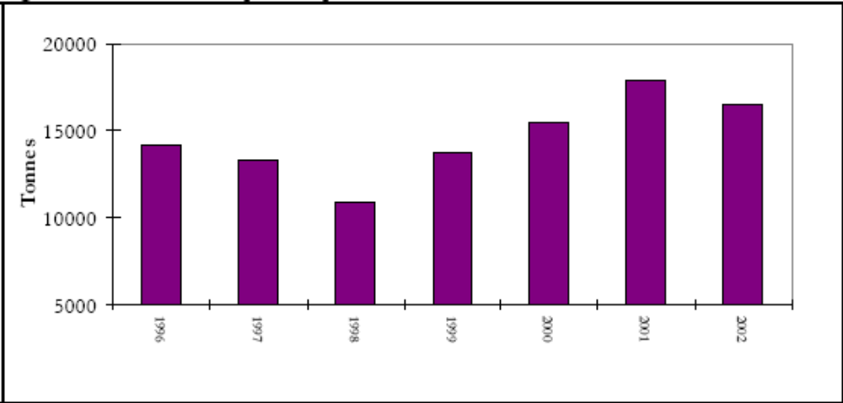
Source: Fisheries Department

Prior to the ban, fishing boats were generally operated by the boat owner or a boat operator on behalf of an absentee owner with a paid crew. The most common form of remuneration allocates a flat proportion of the catch each day to the crew less costs (for example food, fuel, wear and tear of equipment etc) (LVFRP, 1999b). Other forms of payment include the designation of certain days on which the entire catch is divided amongst the crew or the opportunity for the crew to use their own gear to catch fish from the owner’s boat. During the time of restrictions of Kenyan fish exports to the EU, this payment system collapsed.
Most fishers generally undertook other activities in addition to fishing before the ban (LCFRP, 1999a). However, a significant proportion who had diversified their livelihood by investing in a local store or hotel, or by renting out rooms in their own house lost out during the ban. With the opening of non-EU markets and subsequent lifting of the ban, fishing operations resumed but with increased efforts which have impacted negatively on the levels of Nile perch catch from Lake Victoria. Indeed in the year 2002, production reflected a drop of 24.3% compared to previous year’s production. The fishery of this lake in terms of fish catches has been declining year after year since 1999 due to high fishing effort.
By 1997, the industrial fish processing sector employed around 2,400 people, of which 75 percent were temporary or casual workers (Abila and Jansen, 1997). However, there is evidence that overall employment in fish processing has declined significantly over time, reflecting the relatively high levels of capital intensity within the industrial processing sector (Henson & Mitullah, 2004). The need to use competent staff led to replacement of the many temporary workers with few qualified ones, whose role is generally supervision and quality control.
The implementation of stricter standards of hygiene and HACCP-based process controls has also had a significant impact on the wider operations of industrial fish processing facilities. Most processors have employed predominantly casual labour, particularly in more recent years when the supply of raw fish from Lake Victoria has become more sporadic and processing does not occur every day. However, in response to the need for fish handlers to undergo regular medical checks and be trained in basic hygiene practices, some have increased use of permanent and/or contracted labour. Temporary labour now tends to be used predominantly for tasks that do not involve contact with the fish, for example general cleaning operations.

5.4.2 Social Impacts
It appears the ban had a positive effect on Lake Victoria fishers in the area of social activities. In order to address quality problems and illegal fishing practices Beach Management Units (BMUs) were established. The BMUs are registered with the Department of Social Services and demonstrate an improved system of the collapsed cooperative system in Kenya. BMUs bring together all actors at the landing beaches including fishers, traders/agents of processors, manufacturers of fish nets, fish-mongers supplying the domestic markets, boat owners and repairers, and other businesses and individuals affected by fishing. If governance and management structures are enhanced, BMUs provide a social framework on which quality, safety, legal and emerging issues can be addressed.
Perhaps the greatest social impact of the fish ban is the creation of awareness and provision of training on requirements for safe handling of food across the complete fish supply and marketing chain, and in most cases calls for cooperation between and among the various actors. Activities such as fishing, transportation, cold chain maintenance, training and general handling of fish are now more integrated than before the ban.
The Association of Fish Processors and Exporters Association of Kenya (AFIPEK) was established as a direct result of the ban and food safety frequent alerts from the EU. Never before in Kenya’s history had the processors/exporters worked together to address common concerns in fish processing and exports including compliance with government regulations and market requirements. The association pushed its 18 members (10 factories in Kisumu, 4 in Mombasa and 4 in Nairobi) to implement food safety management systems based on HACCP through training and advisory.
Several development assistance programmes were implemented during the ban to help the industry comply with the new export requirements. Many of these came from multilateral agencies such as the African Development Bank (ADB), International Finance Corporation (IFC) and Aga Khan Foundation, as well as government development aid agencies (for example NORAD). Further, indirect support (for example in the form of research, training and technical assistance) was provided by agencies such as FAO, UNIDO, World Bank and UNEP. UNIDO, for example, supported facilities upgrading, development of fisheries regulations and production of a code of practice for the fish industry. The WHO raised the issue of the EU ban due to cholera at the WTO SPS Committee (WTO, 1998a) and further suggested that it would have been better to deal with these concerns through agreements on good hygiene practice for handling and processing of fish aimed at preventing, eliminating or minimizing the risk of any potential contamination. In turn, this led to a fundamental change in the structure and modus operandi of the Nile perch supply chain.
The industrial fish processing sector produces a number of by-products and wastes that also generate value. These are dried and sold on to traders. Waste products, including the fish skeleton (frame), skin, off-cuts and fat are sold to local artisanal processors, either directly or through traders or to industrial fish meal plants. The processed product is bundled and supplied to urban markets throughout Kenya. Abila and Jansen (1997) estimate that 600 people (75% of which are women) are employed in the processing of Nile perch frames and other by-products in Kisumu and a further 400 in Homa Bay and Nairobi. A number of other businesses have come up in form of forward and backward linkages as a result of an organized fisheries value chain necessitated by the ban. In terms of education the ban on exports interfered with regular incomes from fish exports, which increased school drop out rate. According respondents during interview at the landing sites visited, the younger fishermen abandoned fishing to pursue new avenues for income generation elsewhere.

5.4.3 Environmental Impacts
For the last decade ending December 2000, the highest total catch from Lake Victoria was just over 200,000 metric tonnes which was attained in the year 2000 and the lowest catch of about 151,000 metric tonnes occurred in 1992 and 1997. The annual catch tonnage has fluctuated about a mean of 175,000 metric tonnes over the last decade. The average annual catch over the three year period (1998 to 2000) was about 184,000 metric tonnes and the corresponding ex-vessel value at about Ksh.6,978 million (approx. Kshs.7 billion).

Figure 12: Catch Trends of Lake Victoria Fisheries
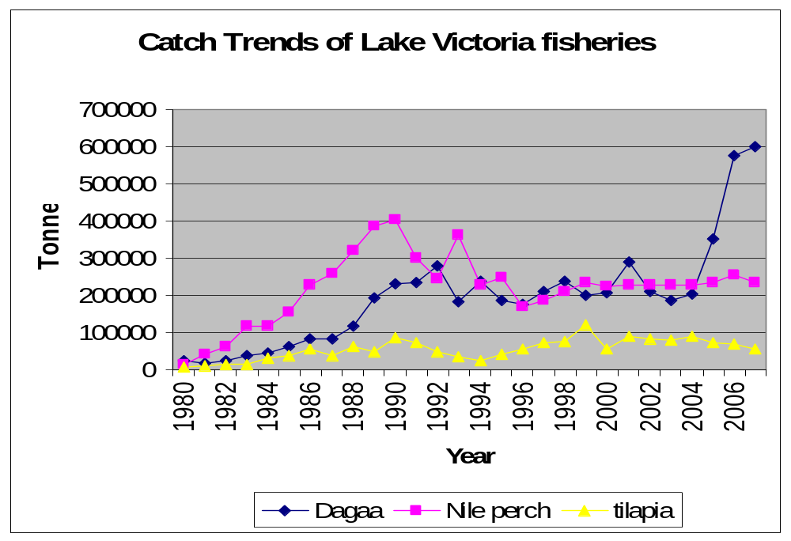
Source: Abila, 2008

From 1998-2000 fish production in the Kenyan waters of Lake Victoria was dominated by two exotic fish species namely Lates niloticus (Nile perch) and Tilapia niloticus (Nile Tilapia) and the endemic cyprinid Rastrineobola argentea. Most of the traditional fish species such as Alestes, Barbus, Labeo, Synodontis, Schilbe and Bagrus seemed to disappear from the commercial fish catches of the lake. Catches of other traditional fish species like Protopterus, Clarias, Mormyrus and once abundant Haplochromis have continued to decline considerably.

Figure 13: Total Catch of Nile Perch (1976-2007)
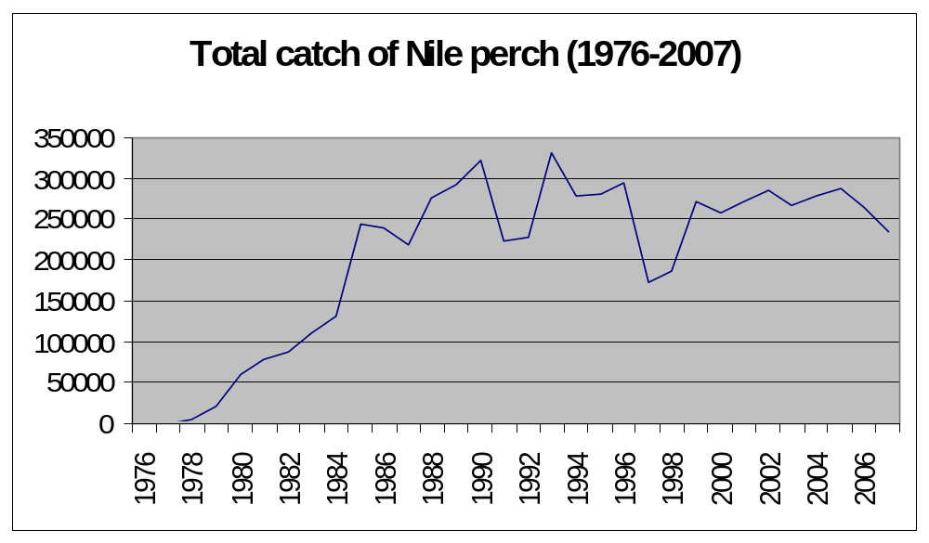
Source: Abila, 2008

It is apparent that Nile perch fishery has come to dominate the fishery of Lake Victoria and brought about fundamental changes in the structure and modus operandi of the entire fish supply chain. More fundamentally, the focus of the supply chain has switched from local, through regional, to industrialized country markets. Local fishing communities have become dependent upon global markets. However, whilst the processing sector has become industrial in terms of both scale and the processes employed, fishing and landing methods remain artisanal in nature. The key factor constraining both the current operation of the chain and its future evolution is the supply of fish (Henson & Mitullah, 2004).
Although the export ban on Kenyan exports to the EU initially reduced fishing of Nile perch in Lake Victoria, the opening of alternative markets immediately opened up the lake to overfishing. Today the most important issue which the three East African countries face is the urgent need to bring the fisheries and any other aquatic resources of Lake Victoria under proper management in order to avoid overfishing. The overall objective is to evaluate the rationale of the existing regulations in order to improve on their weaknesses and formulate new regulations which will support the existence of the stocks. On top of this effort should be made to institute public awareness of these regulations to the fishermen so that their enforcement is more effective. This again calls for interaction linkages between the fishing industry, research, policy making and implementation of proper management of the whole of Lake Victoria fishery.

5.4.4 Institutional Impacts
Because of the many food safety problems and subsequent ban of Kenya’s fish exports to the EU, weaknesses in the Kenyan SPS system dealing with food safety were exposed. Compliance with food safety regulations has not only protected consumers on the export supply chain, but also consumers buying fish from domestic markets. Although more efforts are required in public awareness on food safety matters, the case of EU restrictions on Kenyan fish exports is a case commonly referred to in the management and control of food related problems in Kenya. As responsibility for food safety has not been given to a single government authority yet, the National Food Safety Coordination Committee was established in 2007, to address the multi-sectoral coordination problems on food safety matters. The NFSCC is borrowing heavily from the EU food control system implemented by the European Food Safety Authority (EFSA).
As a result of the ban the Fisheries Department was made the Competent Authority with regard to food safety in fish and fisheries products in August 2000, effectively bringing an end to persistent coordination problems and responsibility overlaps in the previous system under the Public Health Department. This in turn led to establishment of Fisheries Regulations regarding fish safety.
The Association of Fish Processors and Exporters of Kenya (AFIPEK) was formed by 18 industry members in the year 2000 to address emerging issues affecting industry, and in this case to address the fish ban due to non-compliance with EU requirements. AFIPEK focused on HACCP training for all its members, and although 3 factories closed down due to high compliance costs, all the rest got their systems certified.
In line with AFIPEK, a regional association, East African Industrial Fish Processors and Exporters Association (EAIFPEA) was also formed representing fish processors in all the 3 countries sharing Lake Victoria- Tanzania, Kenya and Uganda. The Secretariat is in Kampala, Uganda, but meetings take place on rotational basis in all the 3 countries.
At the lake fishers level, establishment of the Beach Management Units (BMUs) have helped to push management and control of Food safety, quality and regulatory issues beck to the communities. Self- policing mechanisms as well as communal approaches to resource management have proved possible through BMUs. The Fisheries Department has published BMUs regulations that are followed by all fishers operating officially at the landing sites. BMUs have proved useful in curbing illegal fishing practices and have served as entry points for dissemination of information and training.
Laboratory testing capacity on parameters affecting food safety was put to question. The laboratories that had been identified by the CA to analyse official samples did not have adequate capacity to test for heavy metals and pesticides. One laboratory however, even though not ISO 17025 compliant then, The Kenya Plant Health Inspectorate Service (KEPHIS) were recommended for pesticide testing by EU Delegation assessing Kenya’s compliance levels following the ban.

5.5 FLANKING MEASURES

5.5.1 Economic Measures
Fisher-folk and Landing Beaches
Landing beaches improvement was done through community/stakeholder participation. Strategic landing sites were earmarked, with the first phase aiming at fencing; Paving reception areas; Improvement of drainage system; Provision of insulated fish boxes; and Improvement of the sorting sheds. The second phase of beach improvement included Provision of electricity and water; Construction of landing jetties; Modernization of fish reception; and Improvement of access roads.
Infrastructure adjustment costs for industrial fish processors were very prohibitive, thanks to development assistance from multilateral and bilateral donors, and loans from financial institutions. The cost of constructing a new factory to comply with new food safety requirements was averaging between 200-300 million Kenya shillings (3-4 million US dollars) per factory. The bad shape of the facilities necessitated big adjustments and in some cases new factories being established. Some companies opted to set up new establishments rather than upgrade the old ones.
The ban on exports of Nile perch to the EU has served to focus attention on the need for better management of the fishery and, in particular, the importance of co-management in which local communities have an integral role. Indeed, the Kenya Development Plan issued in 2002 has co-management as a priority (GOK, 2002). Further, fishers are increasingly seen as central to the development of infrastructure and the effective management of both the fishery and landing beaches, even amongst fish processors.
A number of investments have been made in beach improvements, although these have not always been coordinated effectively and have proceeded in a piecemeal fashion with funding through a variety of donors.
Industrial Fish Processing
The industrial fish processing sector is aware of the remaining and significant lack of hygiene standards at landing beaches and the potential threat this poses to their own interests. Indeed, AFIPEK established a Beach Development Fund with contributions from its membership. However, its efforts were hampered by the differing attitudes of its members to the importance and/or responsibility for beach improvements.
Over the period 1998-2002 significant efforts were made to enhance hygiene standards within the industrial fish processing sector in order to comply with EU requirements, which had since been embodied in Kenya legislation. Indeed, when the European Commission again undertook inspections in March 2002, it found that facilities met the requirements of EU legislation concerning structure, maintenance and hygiene, with the exception of a few issues that could be corrected relatively easily (European Commission, 2003). Although it is estimated that around 82 percent of installed capacity in the fish processing sector complies with EU requirements as assessed by the Kenyan Competent Authority, a number of fish processing facilities were unable to up-grade their facilities and subsequently stopped operating (Henson & Mitullah, 2004).
In December 2000, AFIPEK published a Code of Good Manufacturing Practice for the Handling and Processing of Fish and Fishery Products in Kenya (AFIPEK, 2000), with funding from UNIDO. The Code covers hygiene practices throughout the supply chain including fishing vessels, landing beaches, auctions, transport, and processing establishments. It aims to provide guidance for compliance with EU and Kenyan legislation and is harmonized with similar codes developed in Tanzania and Uganda.
Increasingly, the fish processing sector in Kenya is recognizing the need to enhance the value added to Nile perch. Given the finite supply of raw fish and the level of excess capacity in the sector, there is a need to move away from exports of chilled or frozen fillets in bulk boxes towards, for example, portioning, breaded fillets or prepared fish dishes. A project jointly funded by FAO, COMESA and CFC is exploring the possibilities for value-addition to Nile perch in the region. The ITC has also funded a visit to observe fish marketing in the UK, Switzerland, Belgium, Netherlands and Germany (Henson & Mitullah, 2004)

5.5.2 Social Measures
In order to continue fishing at the Lake Victoria waters, all fishers were registered under specific beaches subject to BMUs. Through the BMUs, awareness and training were conducted on hygiene and food safety practices. BMUs were assisted to construct fish receiving and handling sites at the beaches (bandas) compliant with Good Hygiene Practices (GHPs). Some of the development partners that supported the BMUs in training and establishment of compliance infrastructure include GTZ, USAID, FAO and UNIDO. The government and some processors/exporters also contributed towards training and infrastructure construction for BMUs. Exporters in particular supported the cold chain by providing refrigerated trucks and ice and in defining safety specifications for fishers as required for compliance with regulations.
As a way of implementing social programmes, BMUs offered a big leverage as they brought together many actors. The objective of having BMUs was to help alleviate poverty and improve the health, welfare and livelihoods of the members through improved planning and resource management, good governance, democratic participation and self-reliance. BMUs were also required to recognize the various roles played by different sections of the community, including women, in the fisheries sector; to build capacity of the members for the effective management of fisheries in collaboration with other stakeholders; and to prevent or reduce conflicts in the fisheries sector.
For all fish landing sites, one of the main social activities is seeking to ensure the safety of its members engaged in fishing including monitoring the safety of fishing vessels at its Beach and take measures to ensure that they comply with applicable safety regulations including provisions relating to the use or personal safety equipment. In this case BMUs are allowed to organize or provide a rescue vessel or services. BMUs are also required to take measures to raise the awareness of members and their families concerning health risks and measures to minimize and prevent diseases including, but not limited to, malaria and HIV-Aids. In terms of pushing compliance among its members, BMUs have provided a forum for training of members in connection with fisheries matters including such areas as fishing techniques, the marketing and processing of fish, and personal financial management. The existence of cooperatives and fishermen’s self help groups at different beaches is a demonstration of the strength of the BMUs and that the local fisher communities have reason to plan, do, check and act together.

5.5.3 Environmental Measures
Catch trends for Nile Perch in Lake Victoria indicate there has been substantial decline in Nile perch biomass since 1993 (Abila 2008). In 1993 the estimated catch of Nile Perch was 330,700 tonnes. In 2005 the catch was 287,000 tonnes and in 2007, it reduced to 234,000 tonnes. The massive rise in fishing effort caused by the lifting of the Nile Perch export ban is a significant cause of this decline, raising the urgent need for management intervention to reverse the current trend.
The biological characteristics of Nile perch have also changed extensively. The most obvious is change in their average length, which has become considerably smaller. This is usually associated with intensive fishing. The fish now reach maturity at a much smaller size and earlier age. As for maximum sustainable yield, Nile Perch stocks are already vulnerable to over fishing and therefore there are seasonal differences in distribution patterns as well as differences in catch rates by fishers. As highest densities of Nile perch is usually in waters of less than 40 meters deep as compared to waters over 40 meters deep, there are less chances of increasing Nile perch catches in the deeper waters. Several efforts have been put in place to arrest the worrying trends in the size and quantities of the Nile Perch in Lake Victoria:
The Lake Victoria Fisheries Organization (LVFO)
In 2004, the Council of Ministers adopted an LVFO Regional Plan of Action to prevent, deter and eliminate, Illegal, Unreported and Unregulated fishing (RPOA-IUU) on Lake Victoria. The RPOA contains agreed measures to prevent, deter and eliminate illegal fishing on Lake Victoria
  - including actions to license and register fishing vessels
  - strengthen law enforcement on the lake
  - promote community participation in fisheries through Beach Management Units
  - a minimum mesh size for gill nets
  - slot size for Nile perch
  - minimum size for tilapia at 25 cm
  - Implementation of the RPOA is underway through legislation and plans of the Partner States.
Building on the RPOA-IUU, the Council of Ministers in March 2007 “considered and adopted the Regional Plan of Action for Management of Fishing Capacity on Lake Victoria” (RPOA – Capacity), and “urged Partner States to adhere to the overall objective”. Implementation of the RPOA-Capacity is underway, but requires further support and agreement on measures to ensure achievement of key objectives.
Self-Monitoring and control by Fish Processors
Whilst the global demand for Nile perch is seemingly ‘limitless’ (at least within the current purview), the processing sector is characterized by significant structural over-capacity. In turn, the exploitation of the Lake Victoria fisheries without due attention to their infrastructural development and effective management is no longer a sustainable strategy (Henson & Mitullah, 2004).
The self-monitoring and control system was started by fish processors in Uganda in September 2007 and in Tanzania in December 2007, and later adopted in Kenya. There is need to continue this industry initiative until processing of and trade in illegal undersized Nile perch has been eradicated.
The Lake Victoria Environment Management Programme (LVEMP)
Efforts to enhance food safety capacity with respect to fish and fishery products and achieve compliance with EU requirements came partly within the objectives of the Lake Victoria Environmental Management Program (LVEMP).The LVEMP covered Kenya, Tanzania and Uganda, with funding from national governments, Global Environment Facility (GEF) and the World Bank. The total project cost was US$77.6 million, of which US$26.9 million was for activities in Kenya (World Bank, 1996). In the case of Kenya project activities came to an end in December 2002.
An aim of the LVEMP was “to maximize the sustainable benefits to riparian communities from using the resources within the basin to generate food, employment and income, supply safe water, and sustain a disease-free environment”. The project consisted of a series of activities, one of which addressed the strengthening of extension, monitoring and enforcement capabilities of national fisheries administrations, with a budget of US$14.1 million (World Bank, 1996).
Specific elements included:
  - Harmonization of laws between countries.
  - Training and empowerment of fisheries law enforcement officers.
  - Establishment of customs posts at selected border landings sites.
  - Promoting organizations of fisher-folk to, amongst other things, monitor fisheries of the Lake Victoria.
  - Establish one fish quality laboratory in each country to carry out tests on microbes, heavy metals, pathogens, pesticides and other contaminants.
  - Study ways to reduce post-harvest losses of fish through improvements in handling and processing and harmonizing data collection
  - Small investments in community water supply from ground-water, sanitary facilities, local roads and health facilities.
This required investment in the construction of community facilities, technical assistance, workshops, training, laboratory and field equipment, vehicles and boats, sanitation, roads and health etc.
Hygiene Measures in conformity with Fisheries Regulations
It must be pointed out that the hygiene measures adopted at the landing beaches through the BMUs and enforceable by Fisheries inspectors have in themselves contributed to improved environmental conditions and the various landing sites. The construction of hygiene facilities have enhanced environmental cleanliness at the landing beaches and boats used on the waters. Besides, the requirement not to use any pesticides (both organic and in-organic) in fishing has checked any illegal contamination of the Lake Victoria waters with chemical. Overall, food safety measures around and within the lake has had a positive effect on human health, fish safety and environmental sustainability.

4.5.4 Institutional Measures
Although the Government of Kenya had established a Task Force to address quality controls in the fish and fishery products sector in 1994, very little progress was made in the period to the end of 1997. The task force consisted of officials from the Public Health Department, Fisheries Department and KEBS, with responsibility to implement coherent and consistent procedures for the approval of fish processing establishments for export to the EU. The task force and was also charged with approving establishments on the basis of inspection reports and otherwise to co-ordinate the activities and responsibilities of the three departments/agencies.
In 1998, European Commission inspectors identified a number of fish processing establishments that had been approved for export to the EU but that failed to comply with EU requirements. Subsequently, the Task Force reviewed all establishments in Kenya. Only one establishment was fully approved for export to the EU, although a further three were given conditional approval whilst non-conformities were being addressed. Five establishments were disapproved and a further four, which had not been exporting to the EU, were prevented from exporting to any country because they did not meet EU requirements (Ministry of Health, 1998a). Further, enhanced and more secure procedures were put in place for issuing Export Health Certificates in the light of two cases of fish processors exporting fish without a permit. These included the nullification of certificates that were missing, introduction of a lockable official seal on Certificates, and security printing of Fish Export Permits.
Over time it became apparent that the involvement of three separate ministries/agencies and in particular communication/co-ordination difficulties and the potential for over-lap of responsibilities was a significant impediment to conformity with EU requirements. Further, the EU itself raised concerns about the manner in which the system operated and its ability to prevent the export of consignments of fish and fishery products that did not meet regulatory requirements (European Commission, 1998). Thus, it eventually was recognized that a single authority was required to regulate the fish and fishery products sector and implement the controls required for export to the EU (Fisheries Department, 2001a).
Initially, the Fisheries Department established Landing Beach Development Committees (LBDC) to plan and co-ordinate improvements at each landing site with a view to achieving acceptable standards (Fisheries Department, 2002). These included District Fisheries Officers, Public Health Officers, Beach Leaders and/or community chiefs, and representatives of fish processors. However, LBDCs did not work well, most notably because of a lack of effective representation of fishers and attempts to impose solutions to capacity problems on local communities.
More recently, the Fisheries Department has established a Lake Victoria Beach Improvement Committee that has identified priority beaches and the required improvements to meet EU hygiene standards. Currently, this has officials from the Fisheries Department and representatives of industrial fish processors, but not local fishing communities. For each of the identified beaches a Beach Improvement Unit (BIU) has been established under the leadership of a fisheries officer. The Fisheries Department has also trained beach inspectors to manage handling of fish and ensure good hygiene on a day-to-day basis. Efforts have also been made to sensitize fisher-folk in the importance of good hygiene and management of the fishery.
Faced with ongoing restrictions on exports to the EU, fish processors recognized the need to present a single voice to the Government of Kenya and the European Commission. Individual processors were also concerned that they were being treated in a similar manner to the rest of the sector in terms of the requirements that were being imposed by the regulatory authorities (Mitullah, 1999). In 2000, the Kenya Fish Processors and Exporters Association (AFIPEK) was formed. The mission of AFPIEK is “To harmonize the highest quality standards in all member industries and promote marketing of Kenyan fisheries products”. Currently it has 18 members, not all of which are operational and include both Nile perch and marine fish processors. It has a staff of two and is funded by member subscriptions. AFIPEK lobbies on behalf of the sector as a whole and attempts to co-ordinate the development of capacity, for example the provision of hygiene facilities at landing beaches, and training of fish handlers. Further, it is increasingly playing a role in ensuring orderly competition within the sector and planning for the sustainable promotion of the sector.
In 2001, the Fisheries Department established a Plan of Action for improving the control of fish and fishery products (Fisheries Department, 2001a; 2001b). The key elements included:
- Countrywide inspection to classify establishments.
- Review of fish processing establishments approved to export fish and fishery products to the EU by the Competent Authority’s Standing Committee.
- Approved establishments to be provided with Permanent Reference Number.
- Completion of first phase of landing beach improvements.
- Training of fish inspectors to familiarize with the new regulations.
- Training of more fish inspectors and trainers.
- Sensitization of fishers and fish handlers.
- Formation and operation of Landing Beach Development Committees.
- Formation and operation of Competent Authority systems audit.
In August 2000, the Fisheries Department was made the Competent Authority and given sole responsibility for food safety controls relating to fish and fishery products and the approval of processing establishments. Further the functions of the Competent Authority were clearly defined, namely:
- Monitor fishing grounds for pollutants.
- Control fish landing, handling and transportation.
- Work with KEBS in establishment of Kenya standards for fish handling and processing.
- Approve the establishment and operation of fish processing plants and vessels.
- Carry out inspection of fish processing establishments to ascertain compliance with
- Kenyan standards and other international standards for fish handling and processing.
- Lay down procedures to be followed for compliance with the Fisheries (Fisheries Quality Assurance) Regulations.
- Approve the establishment of new fish auctions and wholesale markets and carry out inspections.
- Maintain registry of fish processing establishments and vessels, auction and wholesale markets and landings sites approved under Fisheries Act.
A Standing Committee of the Ministry of Agriculture and Rural Development which was the mother Ministry to the Fisheries Department was charged with the management of the Competent Authority (Fisheries Department, 2001a). This is headed by Permanent Secretary and the membership includes the Director of Fisheries and Director of Veterinary Services. This committee is responsible for approving landing sites and processing establishments for export, appointing fisheries inspectors and approving national analytical laboratories for fish quality and safety.
The Fish Quality Control and Inspection unit within the Fisheries Department is responsible for the day-to-day operation of the Competent Authority, including:
- Co-ordination of fish inspection, quality control and assurance.
- Formulation and up-dating of generic HACCP plans, GMP, SSOP.
- Approval of HACCP and SSOP documents of processing establishments.
- Training of inspectors.
- Auditing and verification of field reports.
- Formulation and updating of legislation and standards for fish and fishery products.
- Formulation and updating of inspection procedures and documentation.
The centralization of food safety controls within the Fisheries Department has swept away the prevailing bureaucracy and streamlined procedures and functions. Indeed, it is perhaps no coincidence that the ban on exports to the EU was lifted only three months after the Fisheries Department was made the Competent Authority.
These reforms have also streamlined the procedures for issuing Export Health certificates. A Fish Export Permit is completed by fish inspectors for approval by the Director of Fisheries. An Export Health Certificate is then issued when this Permit is presented at designated offices of the Fisheries Department.
Despite the positive institutional measures taken by the Government of Kenya and the Private Sector, Kenya’s SPS System still requires a lot of improvement. This is with regard to development of legislative and regulatory mechanisms, clarification of roles of various institutions involved in food safety.

5.6 FINAL OUTCOME OF THE BAN

5.6.1 Impact without Improvements- What could have happened?
It is obvious, with the EU regulations on food safety being in force that the only way for Kenyan Nile Perch exports to regain access to EU markets was by implementing a food control system that would guarantee food safety across the Nile Perch Supply chain.
Loss of access to EU markets immediately resulted in a reduction in demand for raw fish as industrial processing facilities ceased operating or reduced output. Because the local market was unable to immediately absorb the surplus Nile Perch, the catch would have declined significantly as fishers reduced their fishing effort. The fishers would have shifted and/or diverted attention to other fish, in particular tilapia. This is because the domestic value chain does not prefer Nile Perch. Alternatively, any Nile Perch in the local market would fetch a much lower price per unit compared with, say Tilapia.
The fact some EU countries continued importing Kenyan Nile Perch on bilateral agreements, failure to implement improvements could have created a situation where the EC would come up with new rules to govern imports by EU member states from other parts of the world. It would also have led to bilateral negotiations especially between Kenya and Italy, Spain and other major markets in the EU.
The opening of alternative non-EU markets during the ban demonstrates that there is a great opportunity for Kenya’s Nile Perch to integrate into diverse global value chains with varying food safety requirements and prices. Although the total volume of exports to non-EU markets would have increased, the value of the exports would be much lower than it is today. This is because the EU market offers cheaper cost options due to shorter distances, and offers better price as well.
It is probable that industrial fish processing plants that closed down due to high upgrading costs would be operational today. However, because of overfishing and the ever declining Nile perch catch trends, the limiting factor mitigating against increased exports to non-EU destinations could have been the limited Nile Perch stocks from Lake Victoria.
Without improvements it is hard to imagine how many other failures in the system would have been raised to date. There would be a high number of food safety alerts for lack of proper food safety controls. All the gains mentioned earlier in the institutional arrangements for food control would be rudimentary as before the ban. Institutions that came up solely to address the problem of the ban would not be in place. These would, for example, include the Competent Authority, AFIPEK, and the BMUs. All other components of the food control system which were developed to address the ban including the legislation, fisheries regulations and conformity assessment procedures would be severely wanting.
Given that the fishers are generally engaged in crop and livestock production as well, some fishers may have changed their occupation to profitable non-fishing activities. Younger fishers may have moved to urban centres for alternative livelihoods.
Environmental problems around the Lake Victoria would have been worse than it is today. Enforcement of hygiene and control of illegal and excessive fishing would be far from control.

5.6.2 Impact with Improvements- Situation now
1. Exports to the EU resumed
With implementation of improvements to EU’s satisfaction, the Nile Perch export bans were lifted, thus giving Kenya access to their traditional export market. Exports to the EU resumed fully in January 2001 and have been consistent since then.
List of Some European importing Markets for Nile Perch Products exported by Kenya (Tonnes)
Table 5: Product: Fish fillets and pieces, fresh, chilled or frozen
Importer | 2002 | 2003 | 2004 | 2005 | 2006 | 2007 | 2008
Netherlands | 1621 | 2748 | 4130 | 4961 | 2385 | 2234 | 1523
Italy | 653 | 884 | 1150 | 575 | 699 | 424 | 542
Portugal | 198 | 322 | 428 | 414 | 1133 | 1224 | 1264
Belgium | 142 | 74 | 400 | 41 | 8 | 617 | 258
Germany | 305 | 381 | 371 | 246 | 565 | 429 | 313
Spain | 44 | 178 | 225 | 171 |  | 940 | 167
Greece | 307 | 537 | 148 | 259 | 134 | 121 | 355
France | 19 | 38 | 100 | 89 | 58 | 63 | 293
United Kingdom | 81 | 102 | 87 | 38 | 19 | 22 | 1
Source: ITC Statistics based on COMTRADE Statistics
2. Nile Perch has remained an important Export product
Although the total Nile perch volumes exported have been reducing from 2003-2008 due to reduced catch at Lake Victoria, the corresponding export values rose over the same period.
Table 6: Volume and Value of Kenya’s Nile perch Exports
Year | 2002 | 2003 | 2004 | 2005 | 2006 | 2007 | 2008
Volumes (Tonnes) | 23448 | 17489 | 16356 | 15940 | 11515 | 11037 | 11670
Values (USD, ‘000) | 22344 | 48492 | 46892 | 52791 | 43599 | 44953 | 50240
Source: ITC 2009 based on COMTRADE statistics
3. Beach Management Units (BMUs)
BMUs have served as important entry points for implementation of food safety, environmental and social programmes at the fish landing stations and for control of fisheries resources and the aquatic environment.
The Fisheries (Beach Management Unit) Regulation (2006) established BMUs with the following objectives:
    - to strengthen the management of fish-landing stations, fisheries resources and the aquatic environment
    - to support the sustainable development of the fisheries sector;
    - to help alleviate poverty and improve the health, welfare and livelihoods of the members through improved planning and resource management, good governance, democratic participation and self-reliance;
    - to recognise the various roles played by different sections of the community, including women, in the fisheries sector;
    - to ensure the achievement of high quality standards with regard to fish and fish products;
    - to build capacity of the members for the effective management of fisheries in collaboration with other stakeholders
    - to prevent or reduce conflicts in the fisheries sector.
4. Association of Fish Processors and Exporters Association of Kenya (AFIPEK)
In 2000, the Kenya Fish Processors and Exporters Association (AFIPEK) was formed. The mission of AFPIEK is “To harmonize the highest quality standards in all member industries and promote marketing of Kenyan fisheries products”. Currently it has 18 members, not all of which are operational and include both Nile perch and marine fish processors. It has a staff of two and is funded by member subscriptions. AFIPEK lobbies on behalf of the sector as a whole and attempts to co-ordinate the development of capacity, for example the provision of hygiene facilities at landing beaches, and training of fish handlers. Further, it is increasingly playing a role in ensuring orderly competition within the sector and planning for the sustainable promotion of the sector.
5. The Lake Victoria Fisheries Organization (LVFO)
In 2004, the Council of Ministers adopted an LVFO Regional Plan of Action to prevent, deter and eliminate, Illegal, Unreported and Unregulated fishing (RPOA-IUU) on Lake Victoria. The RPOA contains agreed measures to prevent, deter and eliminate illegal fishing on Lake Victoria.
6. Competent Authority
In harmony with EU regulations, the Fisheries Department was made the Competent Authority in August 2002, and given sole responsibility for food safety controls relating to fish and fishery products and the approval of processing establishments. The problem of bureaucracy in working with multiple agencies on fish safety has been overcome by having a single competent authority. Perhaps indicating the Commitment of the Fisheries Department to ensure the effective control of fish and fishery product exports to the EU, the first consignments were not approved until 29 January 2001, two months after the lifting of restrictions. This ensured that the facilities that were approved to export were fully in compliance with EU requirements.

6.0 CONCLUSIONS
1. Kenya, until 1996, relied heavily on the EU market for her fish exports. The EU imported 70% of Kenya’s fish exports, with Spain importing the bulk of the commodity. A ban was imposed on Kenyan fish exports by Spain and Italy, on the 27th November, 1996, claiming the presence of Salmonellae in fish. Other EU member States, were however, not influenced by the ban and, therefore, continued to import fish from Kenya on bilateral agreements. On 23rd December, 1997, a ban on fish from East African countries and Mozambique was imposed by the EU as a result of Cholera outbreak in these countries. This ban affected only fresh chilled fish exports, and was lifted on 30th June, 1998. On 26th March, 1999, another ban was imposed on fish from Lake Victoria affecting the three riparian states. This ban was imposed due to alleged use of chemicals by fishers to harvest fish. This ban was lifted on 1st December 2000.
2. As the main market for Kenyan exports until 1996, regulatory requirements within the EU have arguably been the most important drivers of food safety controls in the fish supply chain. Indeed, regulations relating to hygiene in the production and marketing of fish and fishery products in Kenya have, to all intents and purposes, been harmonized with those of the EU. However, attempts to access other markets have exposed Kenyan exporters of fish and fishery products to distinct food safety requirements and alternative forms of conformity assessment.
3. Before the ban on Kenya’s fish exports to the EU, the Kenyan fish sector as a whole had made little progress in restructuring hygiene and other food safety controls. For example, landing beaches had received virtually no attention and in many cases lacked even the most basic of infrastructure. Inspection and other government controls were ineffective and constrained by lack of resources. Many industrial food processing facilities had not implemented HACCP and otherwise did not comply with generally accepted Good Manufacturing Practice (GMP). Further, there was very little co-ordination or cooperation between government and the private sector, different levels of the supply chain, and between the individual industrial fish processors. However, the need to address the concerns of the EU as a means to regain market access brought about wholesale and fundamental change to the sector in a relatively short period of time. More still needs to be done, particularly at the major landing beaches.
4. The immediate response by most processors/exporters was trade diversion into alternative markets outside the EU and diversification of fish export products. As a result of the ban of fish exports to the EU, Kenyan exporters of sought for alternative markets including other industrialized countries such as Australia, USA, Japan and Hong Kong, as well as a number of middle-income countries in Latin America, Asia and the Middle East. The share of exports to non-EU markets drastically rose during the period of the restrictions to EU markets. Although exports of chilled fillets initially stopped, the opening of alternative markets necessitated exports in the form of block frozen fish fillets. The block frozen fish had a significantly lower price than fresh fillets. Besides, the alternative markets generally paid a lower price for Nile perch fish fillets than the EU. The unit value of fish exports was therefore much lower over the period of the ban.
5. In order to lift the ban and regain access to EU markets the Government of Kenya and all actors along the Nile Perch supply chain had to adopt measures that would address the concerns of the EU. As for official national food control system, the Government of Kenya had to update its legislation affecting fish and fisheries products, effectively introducing regulatory mechanisms and institutional frameworks along the complete Nile Perch fishery value chain.
6. The problem of bureaucracy in working with multiple agencies on fish safety has been largely overcome by having a single competent authority. The Department of Fisheries was made the single Competed Authority with regard to fish and fisheries matters and was charged with the responsibility for enforcing fisheries regulations; conducting inspections; approving processing plants and issuing export permits.
7. Beach Management Units (BMUs), whose regulation came into force in September 2005, were institutionalized to increase efforts that would enhance standards of hygiene at landing beaches in response to European Commission inspection reports. BMUs play a crucial role in the strengthening of hygiene controls at the landing beaches; organizing their members into proper organizational structures; controlling illegal fishing practices; and conserving the environment. The improvement of fish landing sites was done jointly between the government, fish processors and the BMUs.
8. One of the most expensive measures was to upgrade the industrial fish processing facilities in order to implement hygiene programmes. The costs of upgrading the structures and implementing hygiene standards in industrial processing facilities to comply with EU requirements were very variable between plants whose facilities were at different levels of compliance. The average cost of upgrading a processing plant was between USD 200,000 and USD 300,000, a cost that made 6 out of the 15 processing plants at that time to close down.
9. The Association of Fish Processors and Exporters of Kenya (AFIPEK) was established with a membership of 18 fish processing companies (10 in Kisumu, 4 in Nairobi and 4 in Mombasa) to bring together fish processing companies to enhance compliance with EU regulations and standards. The mission of AFIPEK is “to harmonize the highest quality standards in all member industries and promote marketing of Kenyan fisheries products”. AFIPEK lobbies on behalf of the sector as a whole and attempts to co-ordinate the development of capacity, for example the provision of hygiene facilities at landing beaches, and training of fish handlers.
10. It is worthy noting that much of the upgrading of processing facilities and food control systems were meant to conform to EU regulations. None of the industrial fish processing facilities ever implemented food safety management standards such as ISO 22000, BRC, Dutch HACCP, IFS, GFSI, etc. This implies that the measures taken to address the ban were largely reactive rather than proactive and elaborates the crucial role the Government of Kenya played in addressing the ban. Although a few processing plants had started installing modern equipment and machinery, there were no specific attempts to have their food safety management systems certified.
11. The EU being the main market for Kenya’s Nile perch exports by 1996, the trade effects of the ban were felt across the whole Nile perch value chain. Kenya was exporting an average of 18,000 metric tons, earning the country about KShs 4 billion Kenya Shillings (over USD 50 million) before the ban. Nile perch fillets constituted over 80% of the total export quantity. As for the processors/exporters, loss in trade volumes was only temporary, as new alternative markets absorbed the Nile perch exports. For exporters who diversified their products and targeted alternative markets, the reduced income was largely due to lower prices both for fresh chilled and for frozen fillets. It should, therefore, be acknowledged that the EU is a very important market for Kenya and every effort must be done to safeguard it.
12. The economic impacts of the ban were felt more by fishers at the landing sites. Initially, no fish was collected by traders/processors from the fishers, and throughout the rest of the period during the ban, the prices dropped drastically. As a result, the fishers received reduced incomes. The number of fishers at the lake also reduced, because the younger fishers moved out to seek for alternative employment and older ones shifted their livelihood to crops and livestock.
13. The social impacts of the ban were in many aspects positive. Hygiene practices at the landing sites improved, which obviously translated into better health practices. The training received during the ban enhanced the understanding of the fisher communities about the importance of observing food safety in their operations. Other social programmes included awareness creation on HIV/AIDS through the Beach Management Units (BMUs) and the training on leadership and management for effective management of hygiene and other requirements at the beach.
14. The environmental impacts of the ban relate to hygienic catching of fish from the lake. Use of pesticides in fishing is illegal just as are poor handling practices at the landing sites. Other environmental measures undertaken during and after the ban relate to sustainability of Nile perch catch from Lake Victoria. Catch trends for Nile Perch in Lake Victoria indicate there has been substantial decline in Nile perch biomass since 1993 (Abila 2008). In 1993 the estimated catch of Nile Perch was 330,700 tonnes. In 2005 the catch was 287,000 tonnes and in 2007, it reduced to 234,000 tonnes. The massive rise in fishing effort caused by the lifting of the Nile Perch export ban is a significant cause of this decline, raising the urgent need for management intervention to reverse the current trend. The biological characteristics of Nile perch have also changed extensively. The most obvious is change in their average length, which has become considerably smaller. The fish now reach maturity at a much smaller size and earlier age. Several efforts have been put in place to arrest the worrying trends in the size and quantities of the Nile Perch in Lake Victoria, including self regulation from industry (fish processors/exporters) on slot size of Nile perch bought and processed.
15. As pointed out earlier, the impact of the EU ban on Nile perch impacts from Kenya exposed the weaknesses in the national food control system and the overall SPS system in Kenya. As there is no single authority charged with responsibility for food safety, major improvements are required in establishing a strong and effective national food control. Indeed there is an urgent need to strengthen the national quality infrastructure for food safety in particular, and the SPS system, in general. This will require high level coordination and deliberations, as well as awareness creation among responsible public and private institutions.
16. The ban by the European Union on imports of Nile Perch from Kenya offers many lessons on the Kenya’s national food control system. Kenya faced a number of challenges while addressing the requirements of the EU market, and the effects of the ban are perhaps more positively skewed in terms of Kenya’s international trade obligations and national development. Although much of the work done was directed towards domestic food control system, it was meant to bring about compliance with EU regulations.

7.0 RECOMMENDATIONS
1. Regional Harmonization and Cooperation on SPS Standards and Measures:
Although all the three countries sharing Lake Victoria were affected by the ban, each country worked on its own food control systems, with limited joint programmes. There is a need to address the challenge of coordination of regulatory activities on SPS matters across East Africa to avoid future problems with compliance. Harmonization of laws and regulations, including implementation of international standards in the SPS area are an essential pre-requisite for regional and international trade liberalization in agriculture, fish or food products. To achieve this, the EAC should establish a harmonized food safety legal framework and cooperation on SPS matters. This calls for awareness raising among policy makers on standards/quality infrastructure in general and food safety and SPS issues in trade in particular. It is also necessary to revise and harmonize SPS measures in the EAC Partner States and conduct awareness at national level on the new EAC Protocol on the application of Sanitary and Phytosanitary Measures. To enhance coordination, there is need to establish a SPS chair in the Directorate of Trade of the EAC Secretariat. Furthermore, there is need to enhance participation of the EAC countries to international forums organized by WTO and Codex. Although Members/observers, the implementation of the requirements adopted by WTO and Codex in the region is far from, is far from satisfactory. There is need to establish regional cooperation on Codex and SPS Committee issues and built common positions during multinational negotiations.
- EAC Regional Harmonization of Food Safety Legal Framework:
The export potential of EAC countries have been incapacitated due to stringent food safety and quality requirement in importing (recipient) countries and weak performance and capacities of the conformity assessment structures (testing, inspection, certification, accreditation, calibration, and traceability).The EAC Secretariat should prepare a Food safety and quality annex to the EAC regional SPS protocol and organize national and regional validation workshops. Once it is finalized, a regional food law on which national food laws will be benchmarked should be enacted. In all the EAC Partner States, most of the legislations and enforcement manuals are outmoded and do not have the holistic/food chain (“farm to table”) approach currently being introduced internationally. The legislations are not prepared for flexible adoption of emerging standards using the “new approach” to keep pace with technology developments, emerging hazards, changing consumer demands and new requirements emanating from the WTO Agreement on the application of Sanitary and Phytosanitary Measures (SPS Agreement). There is need to harmonize technical regulations for food control in each of the 3 countries at the EAC level and develop a common food safety control legal framework coordinated at, say, East Africa Community (EAC) level.
- Regional Awareness raising on food safety/ standards/quality issues for local consumer safety and compliance with international market requirements:
Food safety and quality agencies have little or no attention to distribution of information and advice to all relevant stakeholders along the food chain. As a consequence, the awareness in the population of food safety issues is very low. Fishermen, local suppliers of fish and traders are unable to effectively meet the markets demands in terms of process performance as well as safety and quality related requirements, in particular those relating to enterprise management systems for food safety (such as HACCP/ISO22000). Food safety campaigns including the organization of a food safety week, televised videos and other campaign strategies should be organized to create awareness along the complete farm to fork continuum throughout the EAC as a region. There is also need to create food safety awareness among domestic consumers and promote a culture of food safety and quality within the region.
- Rationalize National SPS Notification System:
With regard to the overall SPS system, Kenya is a member of the World Trade Organization (WTO) and is required to act in accordance with the WTO Statutes. Being a strong exporter of agricultural products Kenya is bound by two WTO agreements specifically affecting agri-food trade: the Agreement of on Technical Barriers to Trade (TBT Agreement) and the Agreement on the Application of Sanitary and Phytosanitary Measures (SPS Agreement). Under the WTO SPS Agreement, each Member has obligations relating to “transparency”. In implementing the Agreement, Members are required to identify a single central government authority to be responsible for the notification requirements of the SPS Agreement, the National Notification Authority (NNA). Also, Members are required to establish a National Enquiry Point (NEP) responsible for answering questions from other Members about SPS measures and related issues. Kenya has identified the Ministry of Trade as the NNA, but SPS Enquiry Points System has designated each SPS Competent Authority as a National Enquiry Point (NEP). It is very necessary that this anomaly be corrected, so that the Competent Authorities remain official Focal Points in the respective SPS dockets. Again there is need to rationalize the national SPS infrastructure to avoid duplication of responsibilities and overlap of mandates.
- Establish National Quality Infrastructure for effective Food Control:
Many crucial elements of the national control system have not been upgraded, including the updating of the national food laws; development of a national food control policy; development and updating of relevant food standards; review of relevant technical regulations; education and training on food safety; accreditation of inspectors, testing laboratories and certification bodies; the need to strengthen coordination mechanisms. Therefore, although much work was done in the line of safety of fisheries products, the overall domestic food control mechanisms should provide a general framework for food control and food safety management.
- Improve National Coordination mechanism for Food Control
The national food safety system in Kenya is managed by various agencies under different ministries and laws. This is with an ultimate aim of promoting public health, protecting the consumer against health hazards and enhancing economic development. Each agency operates independently to fulfill the function for which it was established. However, the activities at each level require integration into a coordinated system. To this end, the National Food Safety Coordination Committee was formed. Lack of co-operation and co-ordination among the many ministries, agencies and other stakeholders involved in the area of food safety and quality resulting in duplications of efforts, waste of scarce public funds and resources, conflicting interests and disorientation of the many stakeholders. The present structure also causes problems in relation to who is the Competent Authority (CA) – an essential element of the administrative structure a food control system. As the Committee has no legal backing, it is extremely necessary to establish a single Food Control Authority that will be charged with sole responsibility for food safety controls in Kenya. The Government of Kenya should establish a food safety authority and an integrated food control system to harmonize operations and enhance coordination.

- Strengthen Capacities for Risk Assessment:
The Government should strengthen capacity to undertake formal risk analysis and enhance national capacity for effective participation in international standards development. There is inadequate capacity to facilitate food safety risk analysis activities in Kenya. Risk assessment and risk management capabilities are required if Kenya is to comply with the WTO/SPS agreement and effectively participate in the development of international food safety standards. Capability and/or capacity to perform risk analyses, including scientific based risk assessment in food safety, plant pest and animal health are scattered or non-existent in institutions attached to government agencies.
- Upgrade National Laboratory Capacities for Testing:
SPS diagnostics and food safety laboratories (chemical and microbiological) are limited in number and performance. Even the existing laboratories suffer from funding limitations and lack of appropriate equipment and qualified personnel resulting in a limited capacity to perform even the most basic analyses. Due to the above, the capacity to analyse important parameters like pesticide residues, veterinary drug residues, and chemical contaminants including PCB, dioxin and heavy metals as well as mycotoxins is very limited. All these are all essential to a number of potential export commodities including fish and emerging food-borne pathogens. There is also a lack of reference materials, proficiency testing and reference laboratories that are important to traceability of measurement standards and participation in proficiency schemes and to achieve accreditation. Reference materials are expensive and limited in availability. Except for a very few SPS-related laboratories, none participate in inter-laboratory proficiency testing. The Government of Kenya should make specific budgetary allocation to upgrade and accredit selected laboratories in Kenya for food safety and encourage best practices in food safety laboratories.
- Increase local capacity for food inspection:
Currently, numbers of trained local and regional inspectors who are familiar with the risk based food safety management concept are inadequate. Training systems for all staff in the SPS systems are generally. The administration and implementation of Food laws requires qualified food inspection services. The inspector is the key functionary who has day-to-day contact with the food industry, trade and often the public. The reputation and integrity of the food inspection system depend largely on the integrity and skill of the inspector. The inspectors available are not sufficiently trained and there is limitation in terms numbers and facilitation to adequately carry out their duties. There is need to update the skills of the Food inspectors so as to keep abreast with the dynamics of Food Safety industry.
- Review Trade Policy Framework:
During the time of EU ban on Kenyan Nile Perch the domestic market for Nile perch was very poor, and with preference for other fish like Tilapia and Rastrineobola argentea (Omena). For traders who pushed their Nile perch trade towards domestic markets, the price was as low as Kshs 27 down from 45 in 1996 before the ban. To date fish processors/enterprises are not in a strong position to introduce in their operations new standards and technical regulations such as for traceability systems required by the EU Directive on Food Safety 178/2002 (as of January 2005). There is a limited number of processing plants and a low level of product diversification and technology associated with export of raw materials and semi-finished products. Kenya’s trade policies and implementation strategies should focus more on diversification of export products and markets to reduce effects of any future export market problems.

- Mapping of SPS related Technical Assistance:
As the existing resources in the whole SPS area in general, and food safety and quality in particular, are scarce and scattered while co-ordination systems seem to be weak at all levels there is need to analyse SPS needs and the technical assistance projects by bilateral and multilateral donors, with a view of harmonizing the approaches and identifying the gaps. This will enable the Government prioritize the needs based on identified gaps and set aside a budgetary allocation to address the gaps. At the same time this will avoid duplication of efforts by various donors/development partners interested in supporting SPS activities in the country/region.
- Develop Measures for Sustainability of Nile Perch Production in Lake Victoria:
Catch trends for Nile Perch in Lake Victoria indicate there has been substantial decline in Nile perch biomass since 1993 (Abila 2008). In 1993 the estimated catch of Nile Perch was 330,700 tonnes. In 2005 the catch was 287,000 tonnes and in 2007, it reduced to 234,000 tonnes. The massive rise in fishing effort caused by the lifting of the Nile Perch export ban is a significant cause of this decline, raising the urgent need for management intervention to reverse the current trend. The biological characteristics of Nile perch have also changed extensively. The most obvious is change in their average length, which has become considerably smaller. The fish now reach maturity at a much smaller size and earlier age. As highest densities of Nile perch is usually in waters of less than 40 meters deep as compared to waters over 40 meters deep, there are less chances of increasing Nile perch catches in the deeper waters. Although several efforts have been put in place to arrest the worrying trends in the size and quantities of the Nile Perch in Lake Victoria, it is necessary to develop strong measures that will reverse the worrying Nile Perch catch trends. Government should set up strict surveillance along the fishing points of Lake Victoria and curb any illegal fishing practices. The self regulation approach currently adopted by industry (fish processors/exporters) on slot size of Nile perch bought and processed should be enhanced.

8.0 REFERENCES
Abila, R.O. (1996). Economic Analysis of the Domestic and Export Marketing of Kenya’s Nile Perch and its Products. Proceedings of 6th FAO Expert Consultation on Fish Technology in Africa, Kisumu.
Abila, R.O. and Jansen, E.G. (1997). From Local to Global Markets: The Fish processing and Exporting Industry on the Kenyan Part of Lake Victoria: Its Structure, Strategies and Socio- Economic Impacts. Centre for Development and the Environment, University of Oslo, Oslo.
AFIPEK (2000). Code of Good Manufacturing Practice (GMP) for the Handling and Processing of Fish and Fishery Products in Kenya. Kenya Fish Processors and Exporters Association, Nairobi.
Bokea, C. and Ikaiara, M. (2002). The Macroeconomy of the Export Fishing Industry in Lake Victoria (Kenya). IUCN, Nairobi.
CBS (2002). Economic Survey 2002. Central Bureau of Statistics, Nairobi.
FAO (2000). The State of World Fisheries and Aquaculture 2000. Food and Agriculture Organization, Rome.
FAO (2002). The State of World Fisheries and Aquaculture 2002. Food and Agriculture Organization, Rome.
Fisheries Department (1995). 1995 Annual Statistical Bulletin. Fisheries Department, Nairobi.
Fisheries Department (1996). 1996 Annual Statistical Bulletin. Fisheries Department, Nairobi.
Fisheries Department (2000). Frame Survey 2000 Report. Fisheries Department, Nairobi.
Fisheries Department (2001a). Report on Handling, processing and Marketing of Fish in Kenya: progress Towards Compliance with National and International Fish Quality and Safety Standards February 2001. Fisheries Department, Nairobi.
Fisheries Department (2001b). Report on Handling, processing and Marketing of Fish in Kenya: progress Towards Compliance with National and International Fish Quality and Safety Standards July 2001. Fisheries Department, Nairobi.
GOK (2002). Development Plan 2002-2008. Government of Kenya, Nairobi.
Henson, S. and Mitullah, W. (2004). Impact of Food Safety Standards on Kenyan Nile Perch: World Bank Policy Research Working Paper 3349. World Bank, Washington DC.
Ikiara, M. (1999). Sustainability, Livelihoods, Production and Effort Supply in a Declining Fishery: the Case of Kenya’s Lake Victoria Fishery. PhD Thesis, Amsterdam.
Jaffee, S. (2003). From Challenge to Opportunity: The Transformation of the Kenyan Fresh Vegetable Trade in the Context of Emerging Food Safety and Other Standards. World Bank, Washington DC.
Jansen, E. (1997). Rich Fisheries-Poor Fisherfolk: The Effects of Trade and Aid in the Lake Victoria Fisheries. IUCN, Nairobi.
Kleih, U., Greenhalgh, P., Marter, A., with Peacock, N. (2006), Sustainability Impact Assessment of the Proposed WTO Negotiations – Final Report for the Fisheries Sector Study; Chatham, UK: Natural Resources Institute; in association with Impact Assessment Research Centre, University of Manchester. Final report: 10 July 2006 (revised);
LVFRP (1999a). Marketing Study. Lake Victoria Fisheries Research Project, Kisumu.
LVFRP (1999b). The Survey of Lake Victoria’s Fishers. Lake Victoria Fisheries Research Project, Kisumu.
Ministry of Health (1998a). Fishery Products Exports and Progress Report on the Status of the Competent Authority and the Establishments. Ministry of Health, Nairobi.
Ministry of Health (1998b). Corrective Actions by the Competent Authority and Comments on Shortcomings Observed by FVO Mission to Kenya on Pesticide Residues Coming from Lake Victoria Carried Out Between 16 and 18 August 1999. Ministry of Health, Nairobi.
Mkisi, M. (1991). Fisheries Socio-economic Surveys for the Tanzanian Side of Lake Victoria. Paper presented at the Symposium of Socio-Economic Aspects of Lake Victoria Fisheries, Bujumbura.
Mitullah, W.V. (1999). Lake Victoria’s Nile Perch Fish Cluster: Institutions, Politics and Joint Action. IDS Working Paper 87. Institute of Development Studies, Brighton.
WTO (1998a). Trade Restrictions in Response to Cholera. Submission by the World Health Organization (G/SPS/GEN/53). World Trade Organization, Geneva.

APPENDIX 1 – LIST OF PERSONS CONTACTED

Person | Position | Organization
Mr Michael Obadha | Assistant Director | Ministry of Fisheries Development, Western Region
Mr Maurice Otieno | Senior Inspector | Ministry of Fisheries Development, Fish Quality Directorate, Western Region
Ms Munira Gilani | Director | Peche Foods, Kisumu
Ms Beth Wagude | Chief Executive | AFIPEK (Association of Fish Processors and Exporters of Kenya)
Mr Mohamed Hussain Sait | Production Manager | Fish Processors (2000) Ltd,  Kisumu
Mr Mathew Ngila | Inspector | Ministry of Fisheries Development, Fish Quality Directorate, Western Region
Boat owners and fishers | Executive Committee members | Beach Management Unit, Ogal, Lake Victoria
Mr Sebastian Xavier K. | General Manager | East African Seafood Ltd, Kisumu
Mr Shafiq Kassam | Managing Director | J Fish, Kisumu
Ms. Evah Oduor | Director, Standards Development & International Trade | Kenya Bureau of Standards (KEBS)
Mr. Barrack Ndegwa | Director, EAC | Ministry of East African Community
Ms. Lucy Namu | Chief Analytical chemist | Kenya Plant Health Inspectorate Service (KEPHIS)
Mr. Robert Kilonzo | Head, Division of Food Safety and Quality | Ministry of Public Health and Sanitation
Mr. Brama Kaleve | Senior Trade Officer | Ministry of Trade
Ms. Wanjiru Kinuthia | Chief Trade Development Officer | Ministry of Trade

